CE Liaison Looker Dashboard Report Descriptions and Instructions

The second of each month you will receive the CE Liaison Looker Dashboard Report. This will come via “Looker” which is a data analysis platform used by Bitfocus. Your dashboard will come as a ZIP file, containing the following excel files with data. Download the zip file and save to one of your permanent files. Once saved, you can click on this to unzip the file revealing the spreadsheets. Below are descriptions of each report and what action you need to take.
______________________________________________________________________________

- CEA Housing Assessors who have Enrolled Clients in CE FYI No Action Needed

This report will tell you your current Housing Assessors, and the last date that they entered a CE project enrollment or created an assessment. There isn’t specific action that is needed from you on this, however, you may want to review to make sure that all the staff on here are in fact active assessors. If not, contact the helpdesk to have their access removed. (Note: They will still retain Housing Assessor access)

No Action Needed

- Active CE users Who Have Not Enrolled a Client in the Last 12 months

Conversely, this report will provide users that either have never enrolled someone in CE System program, or who haven’t enrolled someone in the last 12 months. Unless you have received an exception to keep this person active from CEA, you will need to contact the Bitfocus helpdesk to remove access.

Action Needed: Review list. Contact Bitfocus to remove access or discuss with staff member to determine if they are planning on entering in assessments soon. Contact CEA for any exceptions you may need.

- CEA Enrollments with a CE Assessment but No CLS Assessment

A Current Living Situation Assessment (CLS) is required for all Heads of Household at Enrollment into CE System Agency. This report will show the clients that need to have a CLS entered. These need to be corrected, as it’s a required element for HUD, even if the enrollment is already closed.

Action Needed Open Enrollment in CESP: The CLS assessment needs to be dated the same date as enrollment date. If the client has multiple enrollments into CE System Agency, be sure you are correcting the correct enrollment by lining up the Project Start Date.

Action Needed Closed Enrollment in CESP: If the client record is closed already, you can reopen the client by removing the exit date on the exit screen, save. Add the CLS assessment following instructions above, and then exit again by replacing the exact exit date that was on before. If you don’t remember, it will be listed on the report.

- KC CEA Clients without Contact Information Who Have Agreed to the Release of Their Information

This report will provide you with the clients that are missing contact information who are consenting. Contact information is critical for the CEA team to be able to follow up in the event a housing resource becomes available. Although Contact Information is not required, it’s an important step in the CEA workflow and should be collected under normal circumstances.

Action Needed: Please add contact information for client on the contact tab. CEA will be unable to reach client in the event of a housing resource without the contact information. Report is organized by CE Assessor, follow up with assessors that consistently are forgetting to add contact information.

- KC CE Clients with Contact or Location Info who have NOT agreed to the Release of their Information

This report will provide you with the clients who do not have a consenting ROI in the system.

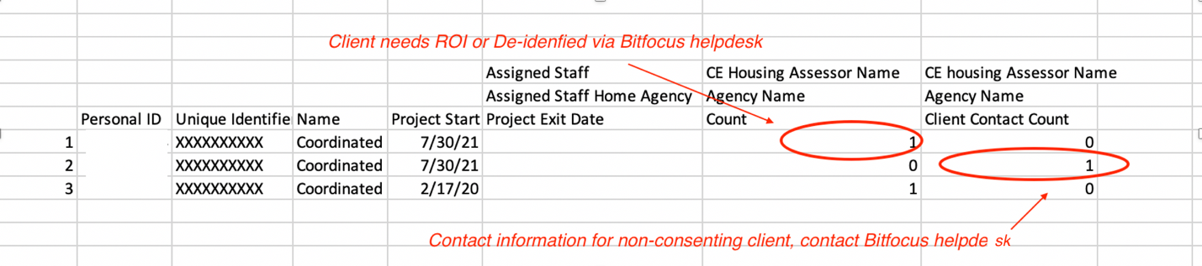

Action Needed: Please contact the Bitfocus Helpdesk (kcsupport@bitfocus.com or 206-444-4100) to have this removed. Please follow up with staff who created the error for further training/reminder.

- Children (under the age of 13) without an adult in CE Household

This report will show you potential data entry errors where there is a child not within a household in Clarity.

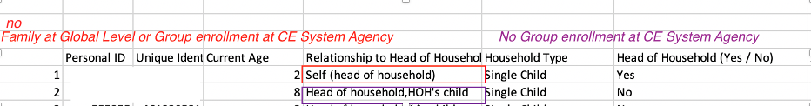

Action Needed: Locate the HoH, and manage them into the household using the manage tab, if not already added to the Global Household. Once added to the Global Household, open the CE System Agency program Enrollment on the HoH, and add them to the program enrollment on the right hand side of the screen. Complete the enrollment screen for the child. On the HTT assessment, add them to the record.

- Non-Heads of Households Assessed Through CEA

This report shows when there are clients that have HTT assessments on the CE System Agency enrollment, but are not the Heads of Households.

Action Needed: You can either make this person the HoH, if so desired by the family, or recreate the assessment on the Head of Household. To make the person the HoH, you will go to the Household Manage tab, and then edit the household member by selecting their name on the top right of the screen. To recreate the HTT assessment, simply open the HoH enrollment, and enter the data using the HTT from the other household member. There is not an automatic process for moving these over.

- Non-Heads of Households that Need to be Exited from CE (Other HH Member has a move-in date)

There should be very few of these records, as the auto exit functionality should exit all family members if they move to permanent housing, indicated in the HMIS system. However, there may be occasions where this doesn’t work.

Action Needed: Review the household’s information, exit the remaining household member from the CE System agency selecting the appropriate destination and save.

- Clients Enrolled in CE System Agency without an HTT Assessment

These clients don’t have an HTT assessment on their record. Meaning, they will never be potentially eligible for the priority pool without the assessment completed. Only actively enrolled clients will appear on this sheet.

Action Need: Please complete an HTT on the HoH and save. If the client is not in need of housing at this time, or is a prevention client, simply exit the client from the CE System Agency.

- Client Potentially Has Incorrect HTT based on age or group enrollment

These are clients appear to have the wrong HTT on their enrollment. This could be because it’s the wrong age category, such as a single adult with a TAY (Transition Age Youth) assessment, or a single adult with a family assessment, for example. Only actively enrolled clients will appear on this sheet.

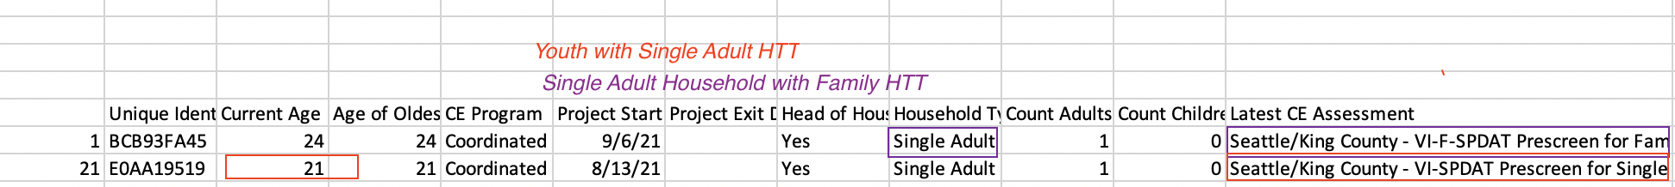

Action Needed: Please review these carefully and ensure that the age of the client is correct, and the appropriate HTT is listed on the client. If not, please create a new HTT that is appropriate. No need to create another CE System agency program enrollment, you can add the assessment to the existing record.

- KC CE Clients Enrolled During the Reporting Period FYI No Action Needed

This is a complete list of the assessments that were generated by your agency since March 1, 2020. This is for your records and information as needed. This may be valuable to determine number of assessments completed by staff member, trends in # of assessments completed, types of assessments completed and household types.

No Action Needed

