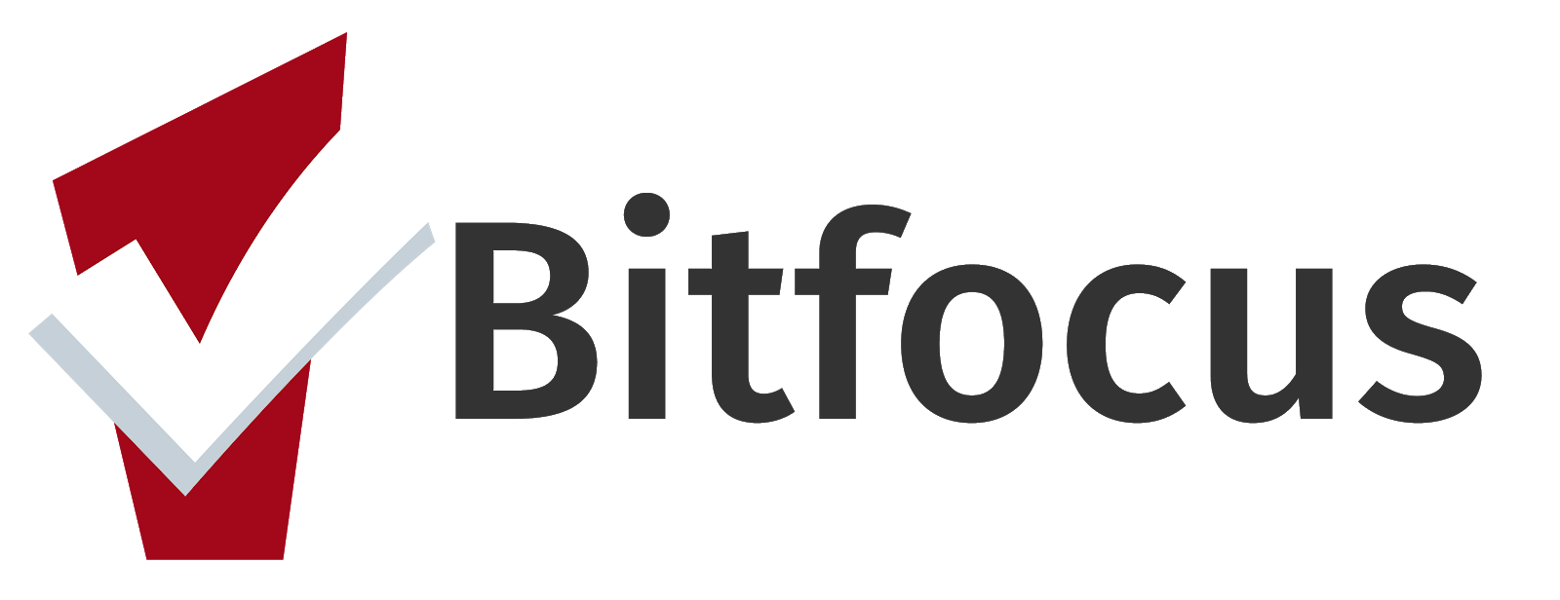
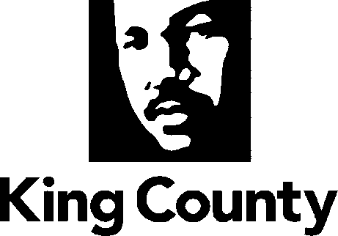
HMIS Participating Agencies
Updated 28 April 2021

Abused Deaf Women’s Advocacy Services | Low Income Housing Institute (LIHI)
Africatown | Mary’s Place
Asian Counseling and Referral Services | Multi-Service Center
Attain Housing | Muslim Housing Services
Cares of Washington | NAVOS
Catholic Community Services -King County | Neighborhood House
Chief Seattle Club | New Beginnings
City of Auburn | New Horizons Ministries
City of Seattle | Pioneer Human Services
Community House Mental Health | Plymouth Housing Group
Compass Housing Alliance | Public Health of Seattle/King County – HCHN
Congregations for the Homeless | Refugee Women’s Alliance
Consejo Counseling and Referral Service | Renton Ecumenical Association of Churches
Domestic Abuse Women's Network | Real Escape from the Sex Trade
Downtown Emergency Service Center | ROOTS
Downtown Seattle Association | Seattle Compassion Services
El Centro de la Raza | Seattle Indian Center
Elizabeth Gregory Home | Seattle Indian Health Board
Evergreen Treatment Services | Seattle Housing and Resource Effort
FareStart | Snoqualmie Valley Shelter Services
First Place School | Solid Ground
FOB Hope | Somali Youth and Family Club
Friends of Youth | Sound
Fusion | St. Stephens Housing
Harborview Medical Center Mental Health | St. Vincent de Paul - King County
Hopelink | The Salvation Army - King County
Hospitality House | The Sophia Way
Housing Connector | Therapeutic Health Services
Imagine Housing | TRAC Associates
Immanuel Community Services | Transitional Resources
Kent Youth and Family Services | United Indians of All Tribes Foundation
King County Coordinated Entry for All | United Way of King County
Lake City Partners Ending Homelessness | Urban League of Metropolitan Seattle
Lifelong | Uplift Northwest
Lifewire | VA Puget Sound Health
 | Valley Cities Counseling and Consultation

HMIS Participating Agencies
Updated 29 March 2021

Virginia Mason Medical Center | Wellspring Family Services
Washington Department of Veteran Affairs -  King County | YMCA of Greater Seattle
Weld | YouthCare
Wellspring Family Services | YWCA of Seattle, King and Snohomish Counties - King County

