How to Exit from the Marin Coordinated Entry Program
Definitions of HMIS Exit Terms
Destination | Where they go
Housing Assessment Disposition | Why they are being exited from the program and what CE’s relationship is to them.

Exit Scenarios
When to exit a person from Coordinated Entry:
A person is exited from the Coordinated Entry Program under the following conditions:
- They get Permanent Housing via our resources (PSH, PH or RRH)
- They self-resolve by finding housing with friends or family
- Their whereabouts are unknown for longer than 90 days and our outreach teams and service providers indicate they no longer know where they are.
Note: if a person is in Shelter or Transitional Housing (e.g., Mill Street or Homeward Bound Family Center, Next Key) they are still homeless and are not to be exited from Coordinated Entry until they self-resolve or have a permanent solution.
When not to exit a person:
- A person is still homeless, in a shelter, or transitional housing
- A person has been active in HMIS with a service or engagement in the last 90 days, our outreach teams indicate the person is still in the County

How to Exit a Person from Coordinated Entry Program in Clarity

PSH Scenario
Examples: 4th street, Palm Court, Buckelew HUD, Vouchers (HHS, Mainsteam, VASH and S+C) , Carmel
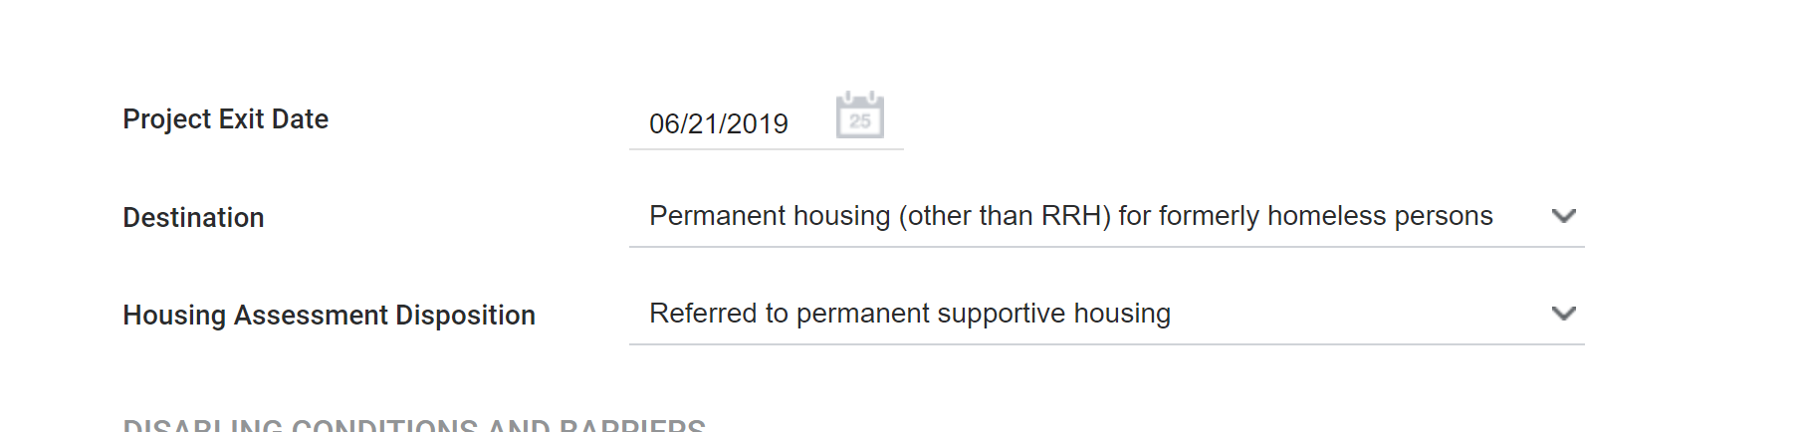

PH but Not S (Permanent Housing but not Permanent Supportive Housing)

(i.e., no disability requirement)

Examples: King Street, Oma Village
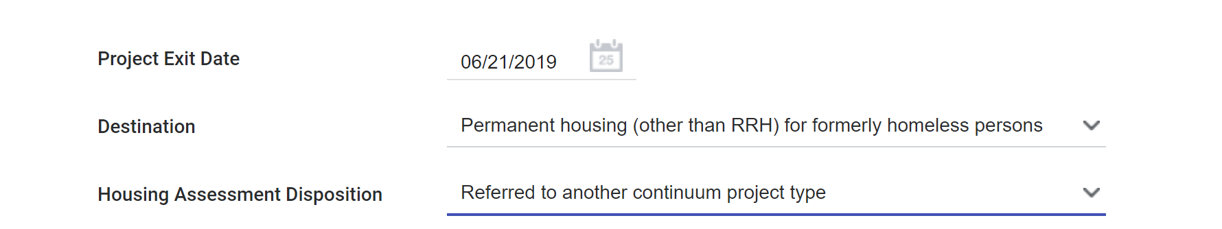

Scenario: RRH (Rapid Rehousing)
Examples: CalWorks, Any County RRH, e.g. Vinnies, Adopt A Family RRH or ESG

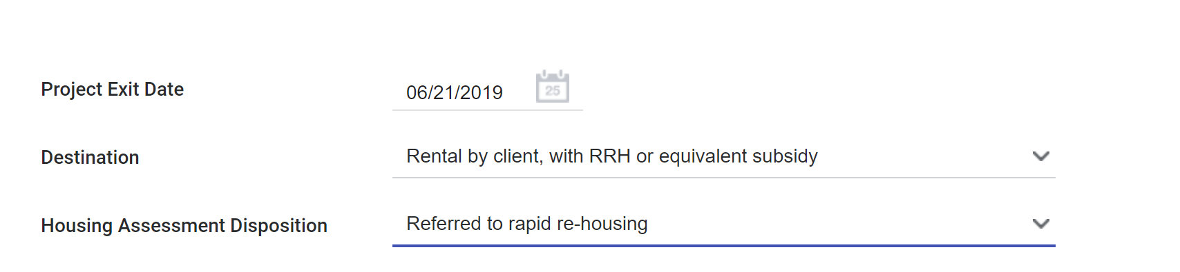

Scenario: Deceased

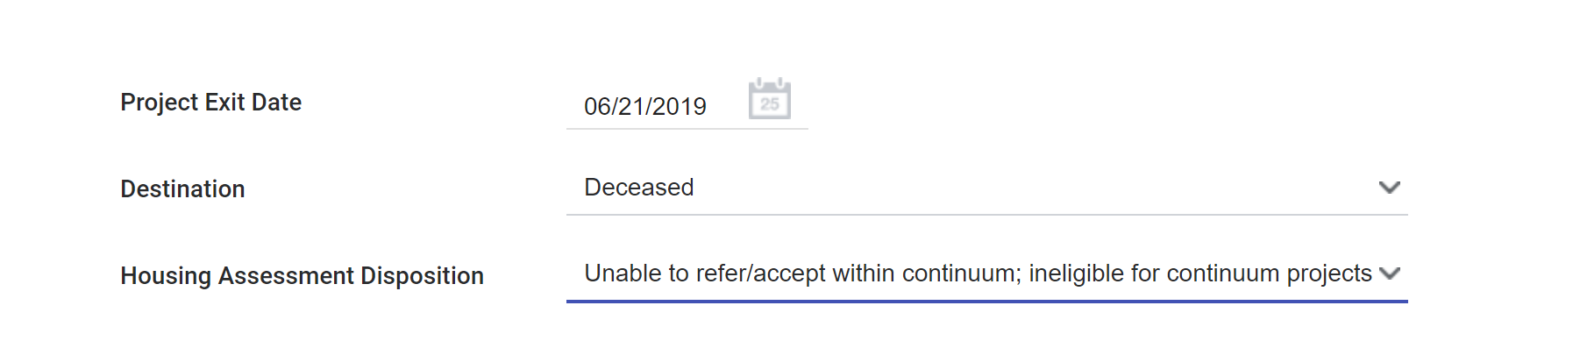

Scenario: Staying with Family and Friends

Note: default to “temporary tenure” unless the exiter says it is permanent. We go with the client’s definition.

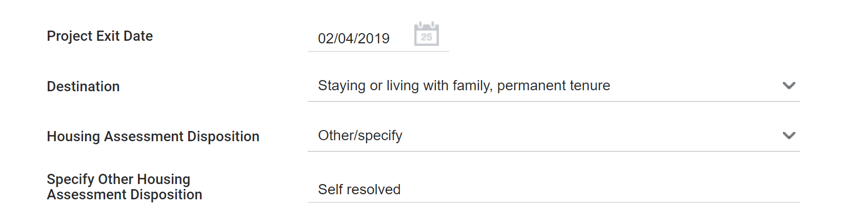

Scenario: Out of County for extended period of time
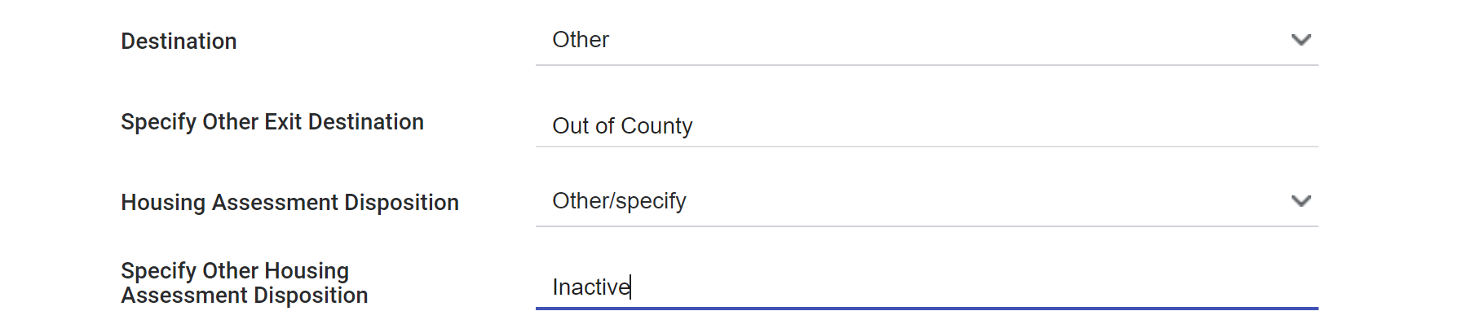

Scenario: Whereabouts Unknown
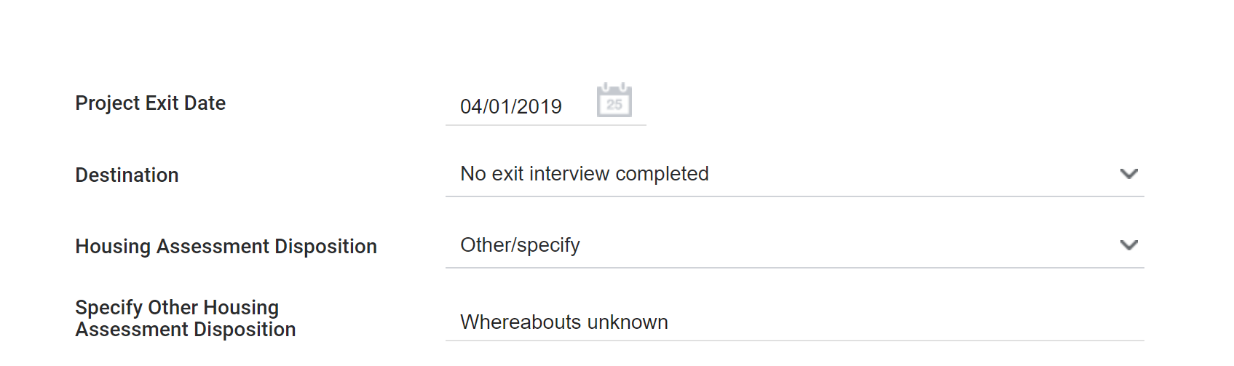

Long term Facility

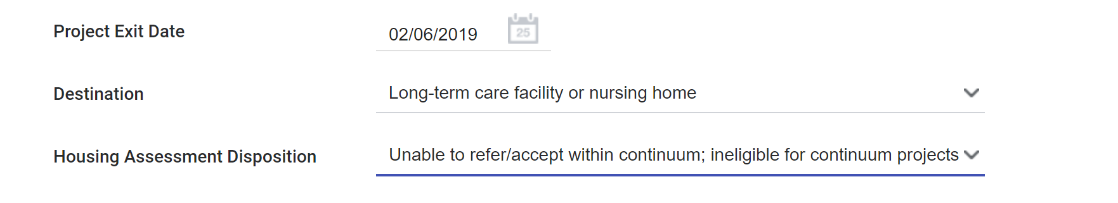

Rental by Client with no Subsidy/non-homeless subsidy (e.g. Section 8 not through Coordinated Entry)

