Referring to the Community Queue
After completing the Assessment, you will see an option to refer the client to the Community Queue (figure 1). For some assessments, you will see a toggle for more than one queue. Turn on the toggle for the resources the client is eligible for. 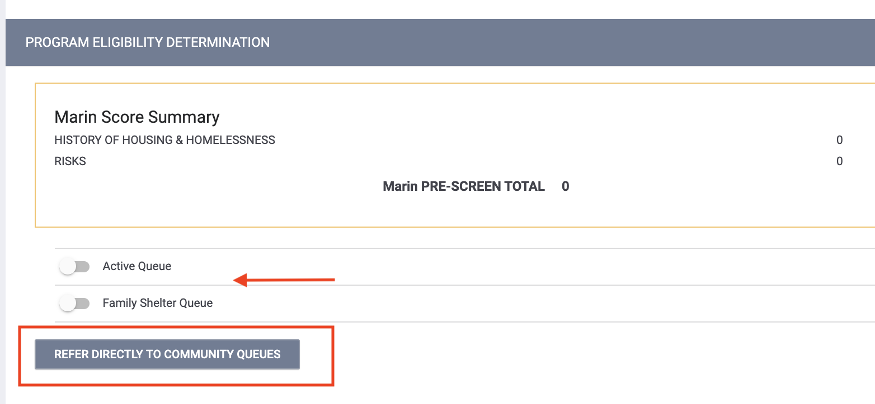

figure 1
On the next screen, enter any applicable notes and click Send Referral (figure 2).
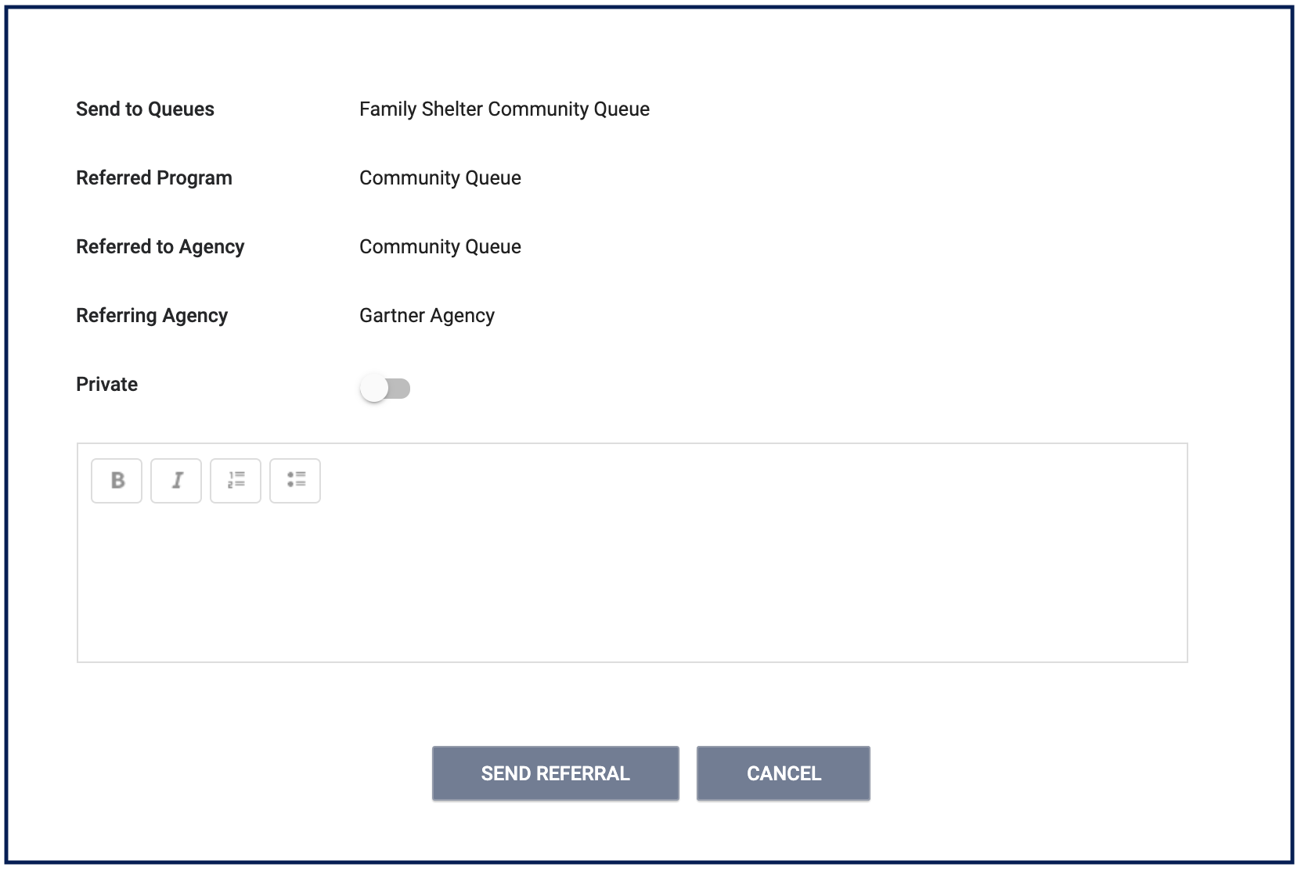
figure 2
Using the Community Queue
To view the Community Queue, click on Search, select the Referrals tab (figure 3), then select the Community Queue.
There are two separate Community Queues. 1) Family Shelter Queue and 2) Active List. You can navigate between the two queues by clicking the name of the queue. The queue you are currently on will be blue (figure 4).
Note: If a client is on both queues and removed off of one, they still remain on the other queue.
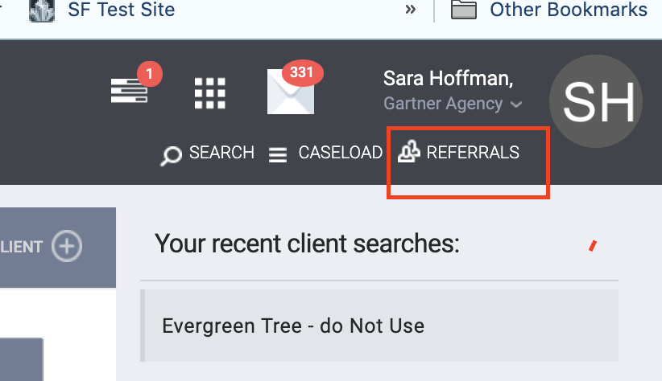
figure 3
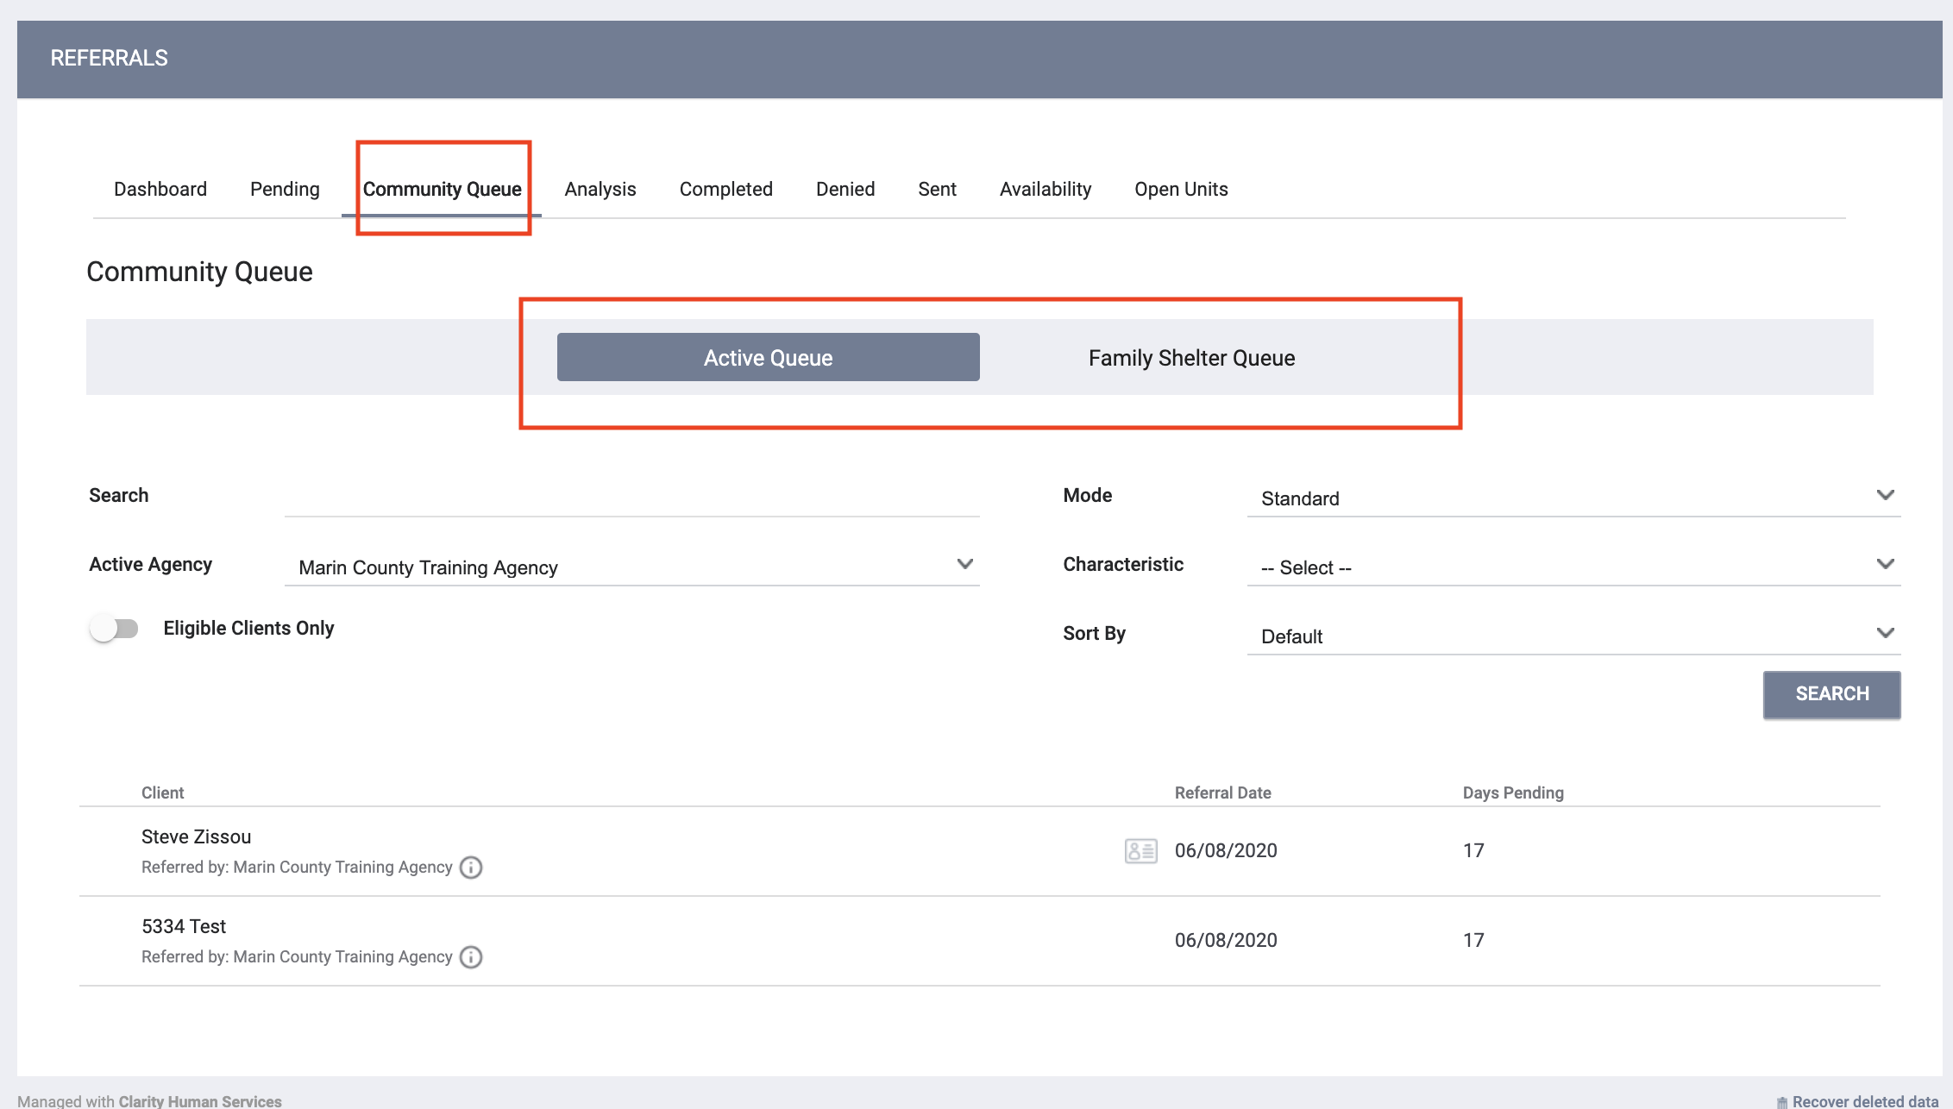
figure 4

Searching The Community Queue For Clients
The Community Queue is equipped with multiple filters giving you full control over the information searched for. The unified search box allows for different types of criteria to be entered, either on its own, or a combination with other terms. Reference the terms below:
Enter search parameters and click Search:
- Search - Client Name, UI, SSN
- Mode - Assessment Type (e.g VI-SPDAT Prescreen for Families [V1])
- Active Agency - Matchmakers should select the agency they are making the referral to
Note: If searching for a particular client, enter the client’s name, unique ID or SSN in the search box.
Once an assessment is selected under Mode, the assessments scores will be visible for each client on the queue (figure 6). Clients will be prioritized listing the client with the highest assessment score first and then days pending on the queue as the tie breaker.
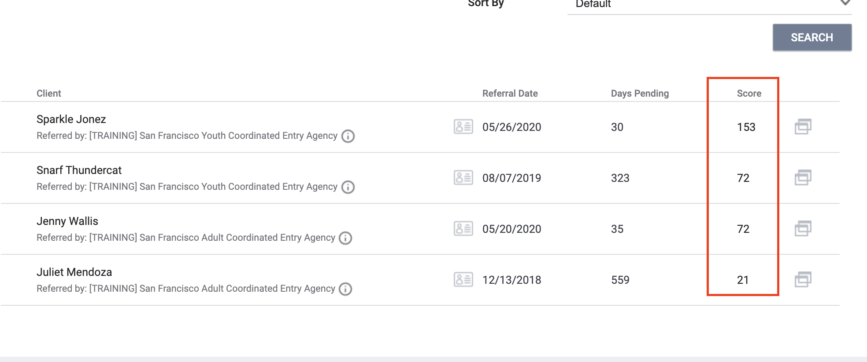
figure 6
Referral: Assign
Re-assigning the referral is how Matchmakers refer a client to a program. Edit the referral, select the program and click Save (figure 7).
Matchmakers can add referral notes if needed.
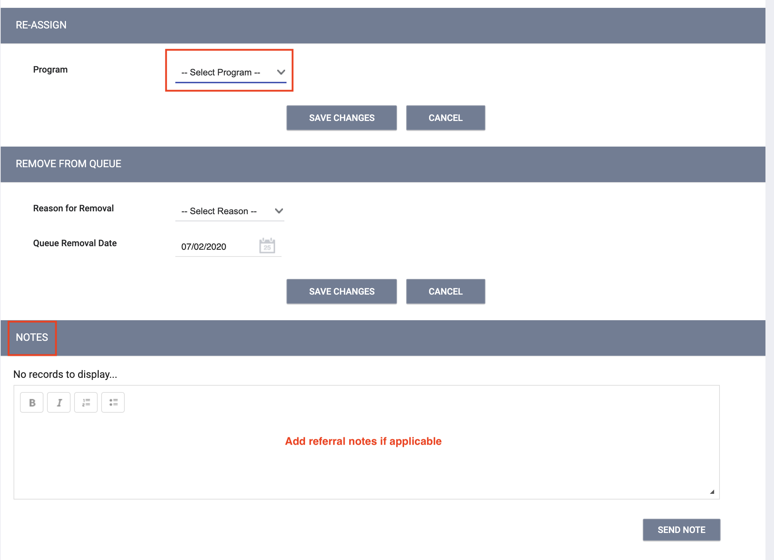
figure 7

