Marin- Problem-Solving Services

How to Enter a Problem-Solving Service for Coordinated Entry

- Go to the Client’s Enrollment and click the Provide Services Tab (figure 1)
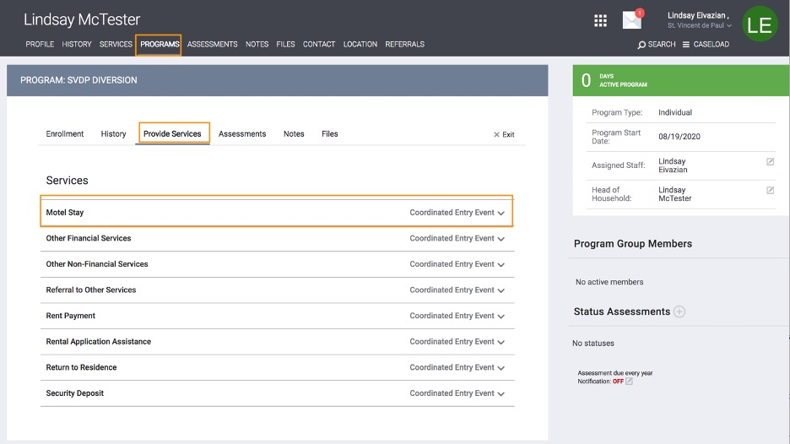
figure 1

- Select the Diversion service that the client is receiving (figure 2)
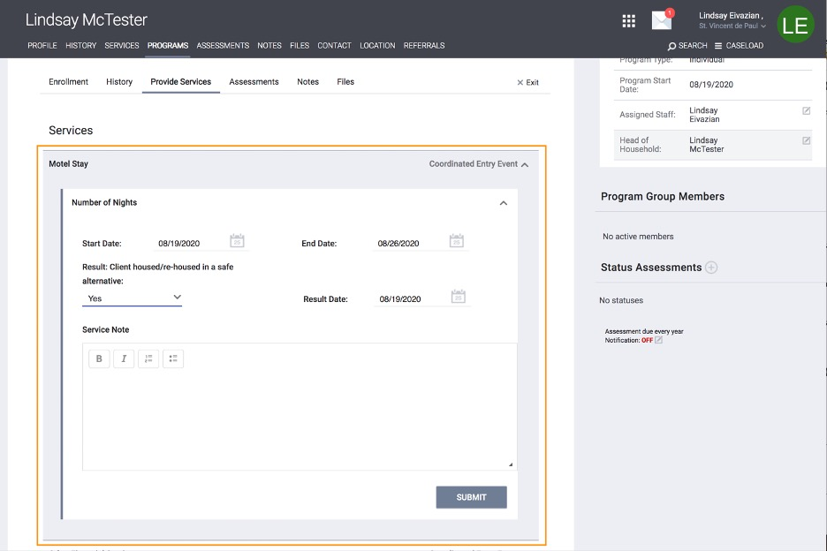
figure 2

- Enter the date of the service (figure 3)

- *NEW* Specify whether or not the service is resulting in the client becoming housed/re-housed in a safe alternative and the date that the event occurred. (Note: If Yes, exit the client from CE) (figure 3)

- Click Submit when done (figure 3)
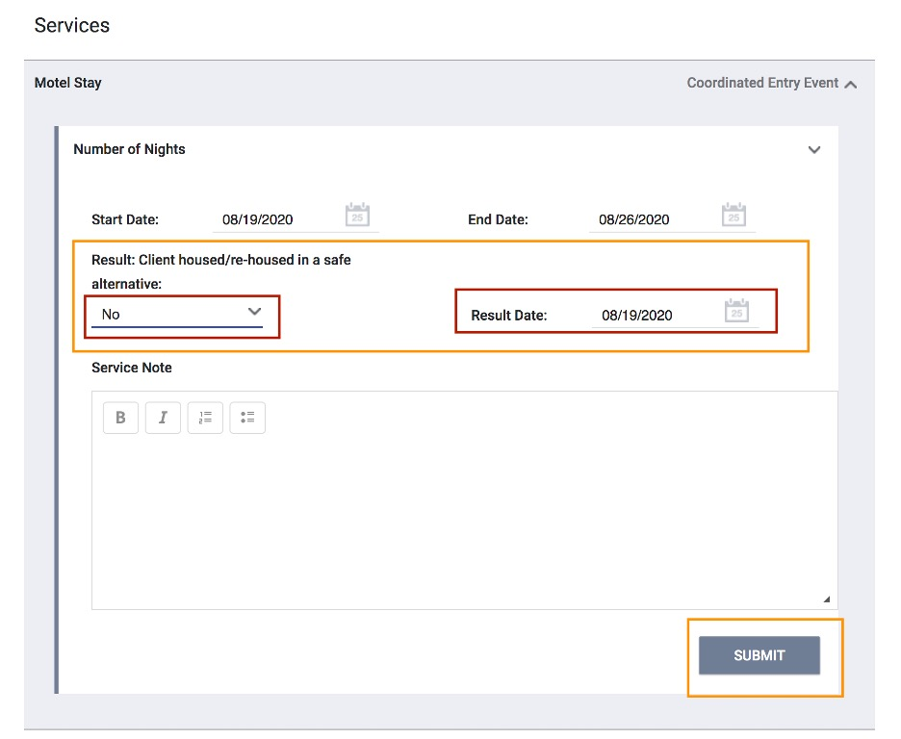
figure 3

