Updating the Status of a Referral
To update the status of a referral, navigate to Search > Referrals. If you do not see the Referrals tab, click Search to go back to the home screen and it should appear.
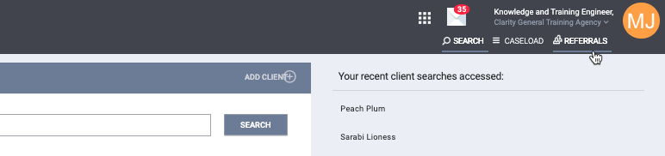
figure 1
Locate the referral you would like to update the status for. Click the edit icon next to the referral(figure 2).
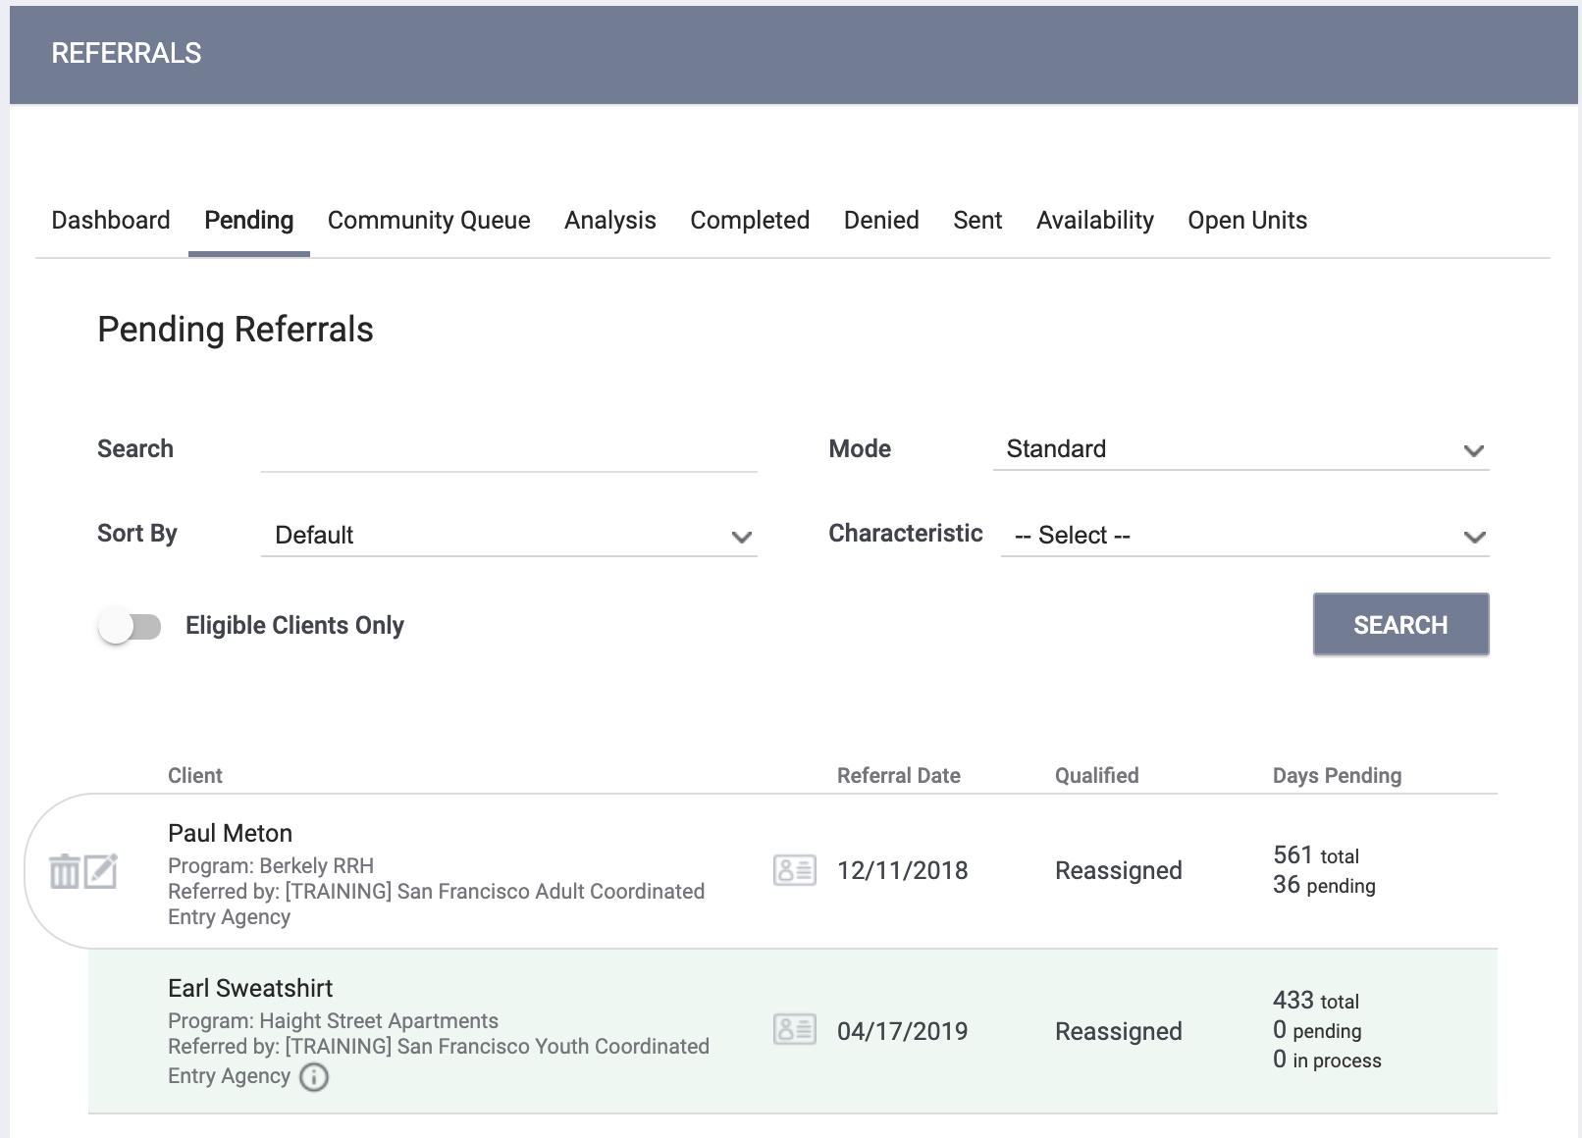
figure 2
Scroll down to the Status field. Here you’ll see your status options (figure 3). The status of a pending referral can be updated to "Pending - In Process", "Denied" or "Expired".
Note: When a referral is first received, the provider should change the status from to pending-in process within 48 hours.

figure 3
If “Denied” is selected, additional fields will display (figure 4).

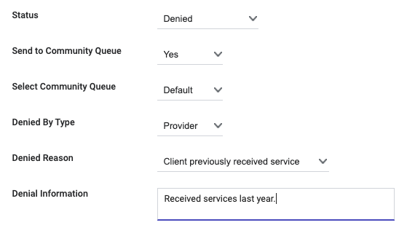
figure 4
- Denied by Type: allows the user to indicate if the referral was denied by the agency (“Provider”) or if the client declined services (“Client”).
- Denied Reason: the reason the referral was denied. This field is required.
- Denial Information: a text box to record a note about the reason the referral was denied. This field is required.
Accepting a Referral
When enrolling a client or household in a program, you can indicate the enrollment is the result of an open referral by toggling on “Program Placement a result of Referral provided by (referring agency)” (figure 5). When the enrollment is recorded with this toggle on, an end date will be recorded for the open referral, and the enrollment information will be added to the Referral Connections section.

figure 5

