ONE System Family CE Shelter Placement Process

This document will outline the process to get a family onto the individual shelter room placement list, getting them verified as unsheltered, reviewing the placement list, connecting the family to congregate shelter, and the process for referring the highest priority family to an individual shelter room.

Complete the Shelter (Individual Room) Placement Criteria Assessment
Step 1: Click the program level “Assessment” tab. Note: You must be in the client’s Coordinated Entry program enrollment screen to see this assessment tab.
- Families interested or in need of shelter should complete a ‘Shelter (Individual Room) Placement Criteria’
- Prior to completing the “Shelter Placement Criteria” check the client’s History or Assessments tab to see if they already have one completed.
  - A new ‘Shelter Placement Criteria’ should only be created if they have already gone through the shelter placement process and they are starting it over again.
- If they already have a ‘Shelter Placement Criteria’, that existing criteria can be referred to the Emergency Shelter CQ.
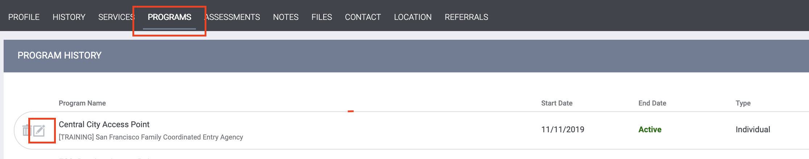
Step 2: Click “Start” next to the ‘Shelter (Individual Room) Placement Criteria’
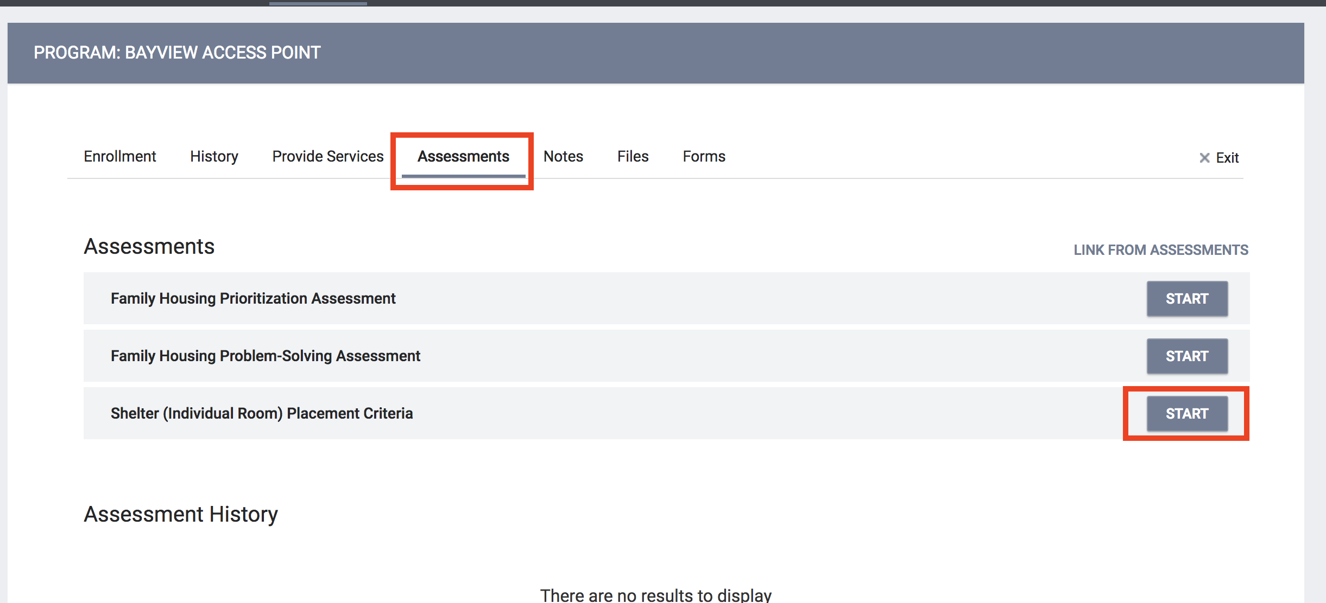
Step 3: Begin filling out the ‘Shelter Placement Criteria’
Note: If the family is currently residing in an unsheltered location, they will need to be verified as unsheltered to be eligible for placement at Hamilton Family Congregate Beds. To get them on a list to be verified, activate the “Does this family need to be verified unsheltered?” toggle in their ‘Shelter Placement Criteria’.
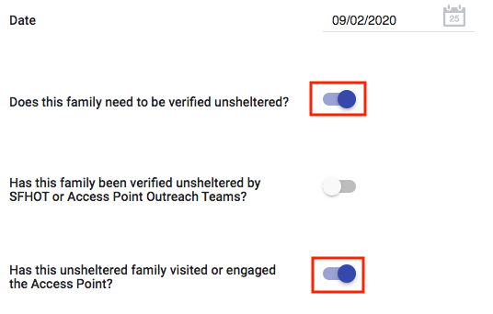
Step 4: Complete the ‘Shelter Placement Criteria’ indicating how many clients in the Household are in need of shelter. Once complete, select “Save” at the bottom of the assessment.
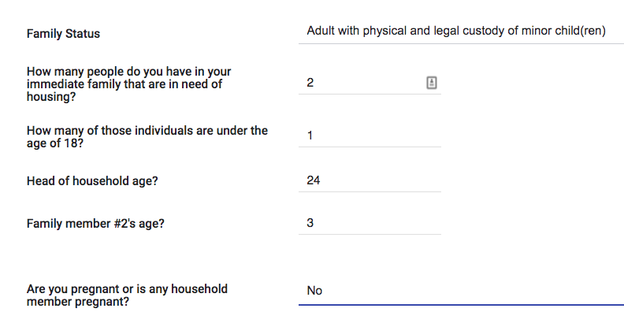
Step 4: Once the family has been verified as unsheltered, the ‘Shelter Placement Criteria’, should be referred to the Family Shelter and TH queues at the same time. Families do not need to have Housing Referral Status to be referred to the TH or shelter queues.
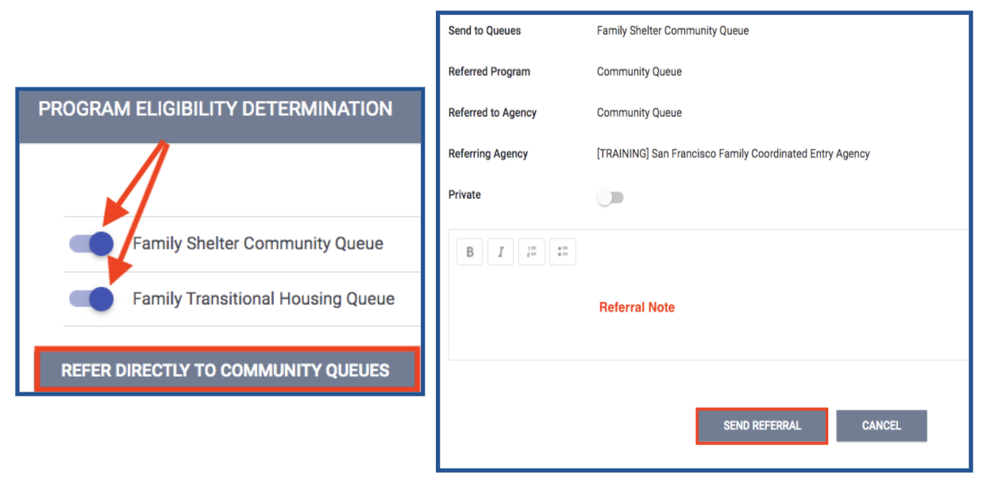
Step 5: If a family already has a completed ‘Shelter Placement Criteria’, it can be referred to the Family Shelter and TH CQs by selecting “Eligibility” next to the most recent ‘Shelter Placement Criteria’ assessment on the client’s Assessment tab.
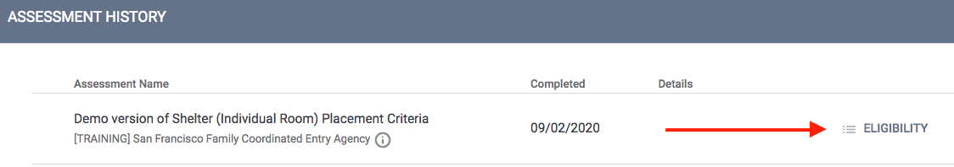
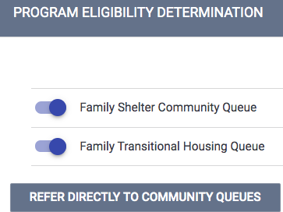

Entering the Family’s Location and Contact Information
Entering the family’s location will assist outreach teams in finding the family to verify that they are unsheltered. Adding current contact information will also aid in the location efforts.
Step 1: Click the “Location” tab. Complete the necessary fields. Note: location Name, Address (line1), and City are required fields.
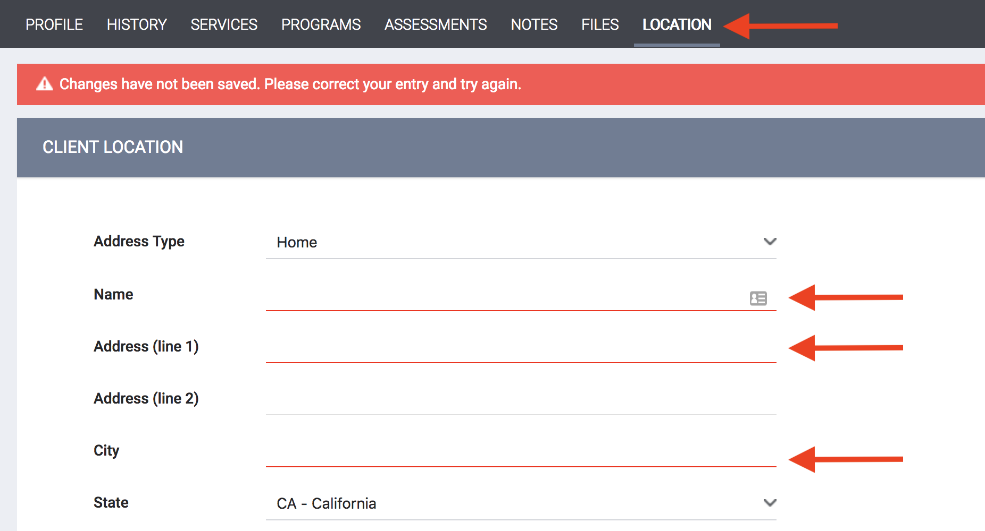

Step 2: Switch to the “Contact” tab and enter the family’s current contact information.
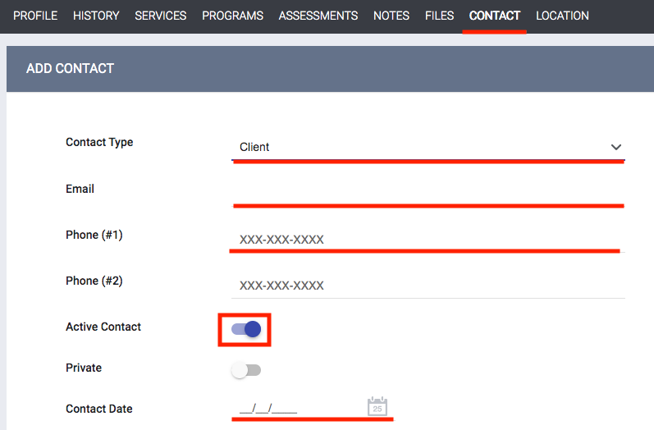
Step 3: The family’s location will now show on the “Families Who Need to Be Verified Unsheltered for Individual Shelter Room Placement” dashboard. The AP Mobile Outreach Teams will be responsible for verifying that a family is unsheltered. Their contact and location info can be identified by selecting the client on the Map or by using the tables on the bottom of the dashboard.
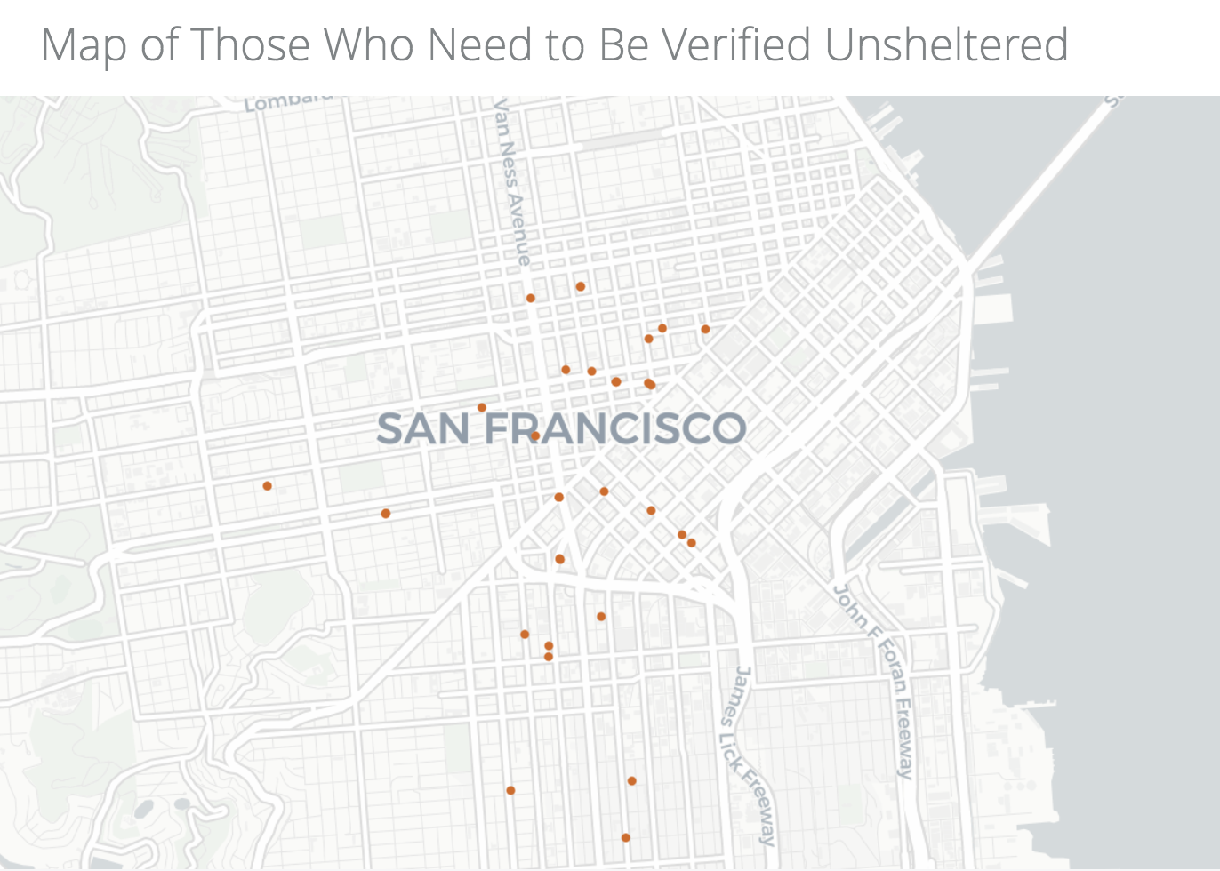

Step 4: Once the outreach team locates the family, they will indicate the family is unsheltered using the ‘verified unsheltered toggle’ in the ‘Shelter Placement Criteria’. Click on the Head of Household’s “Assessment” tab.
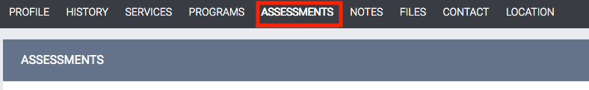

Step 5: Scroll down to “Assessment History”. Click the edit button to the right of the ‘Shelter (Individual Room) Placement Criteria’ assessment.
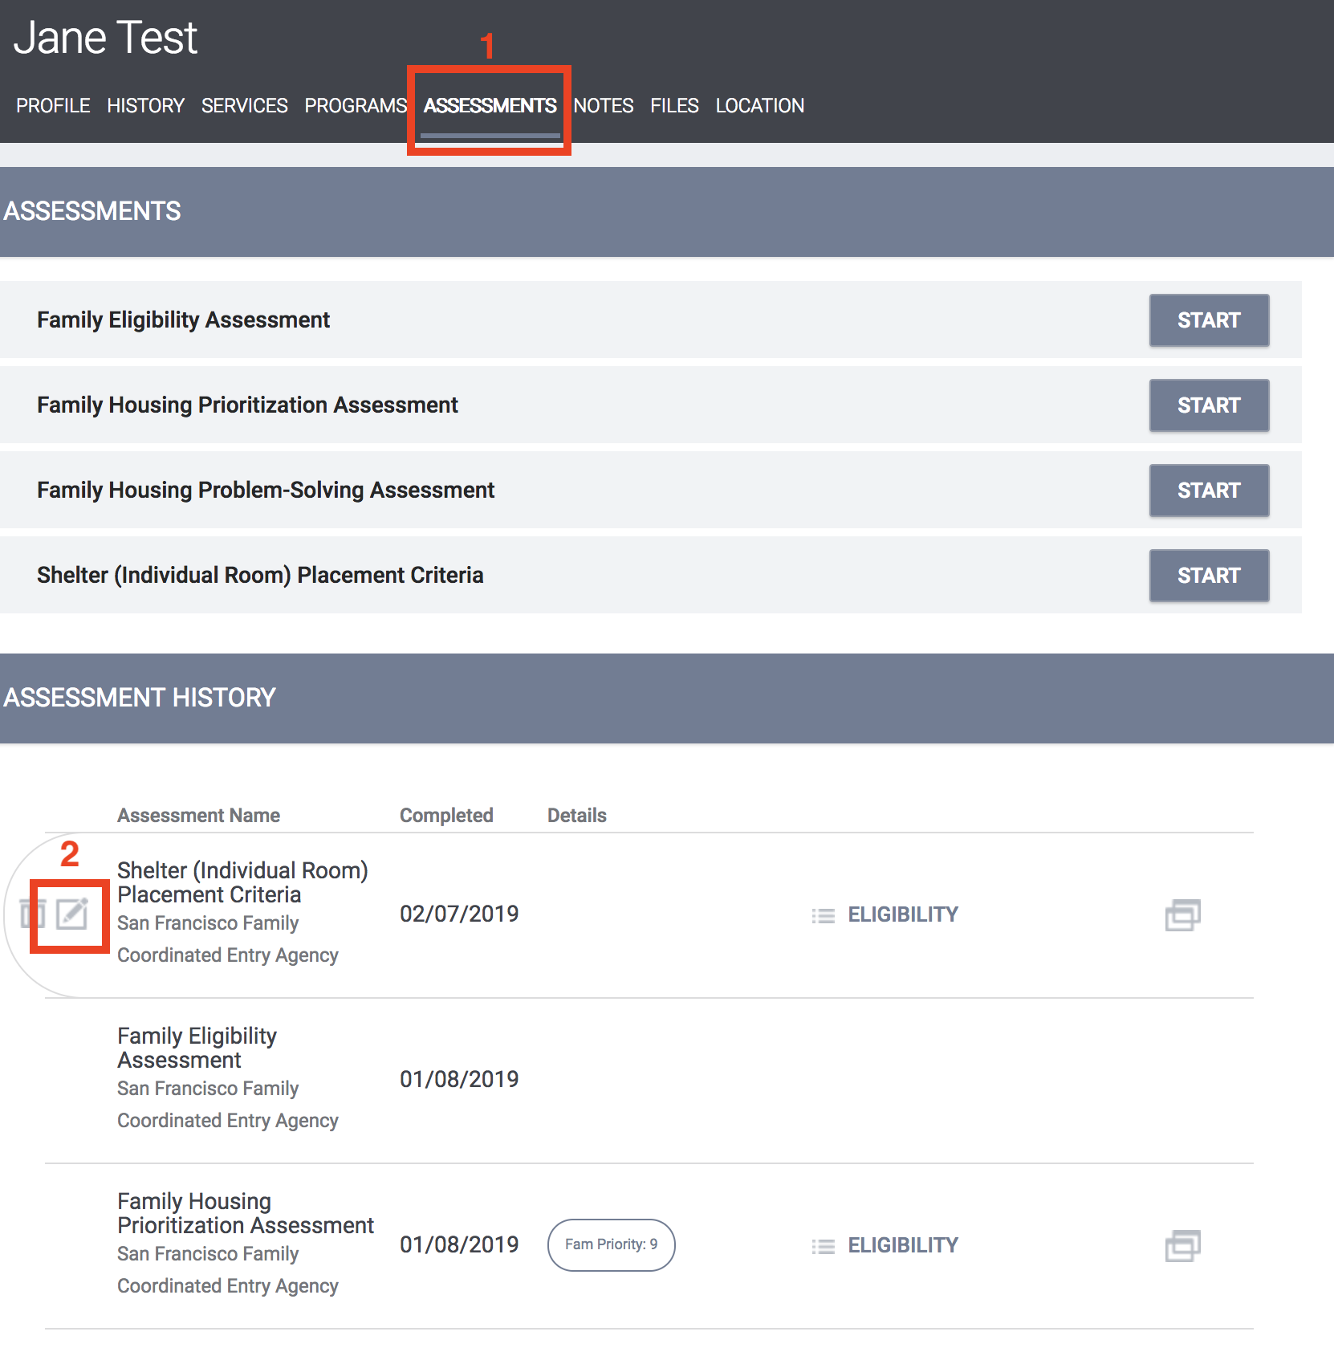

Step 6: Toggle on the “Has this family been verified unsheltered by SFHOT or Access Point Outreach Teams” and enter the date the family was verified unsheltered.

Step 7:Toggle off the “Does this family need to be verified unsheltered”.
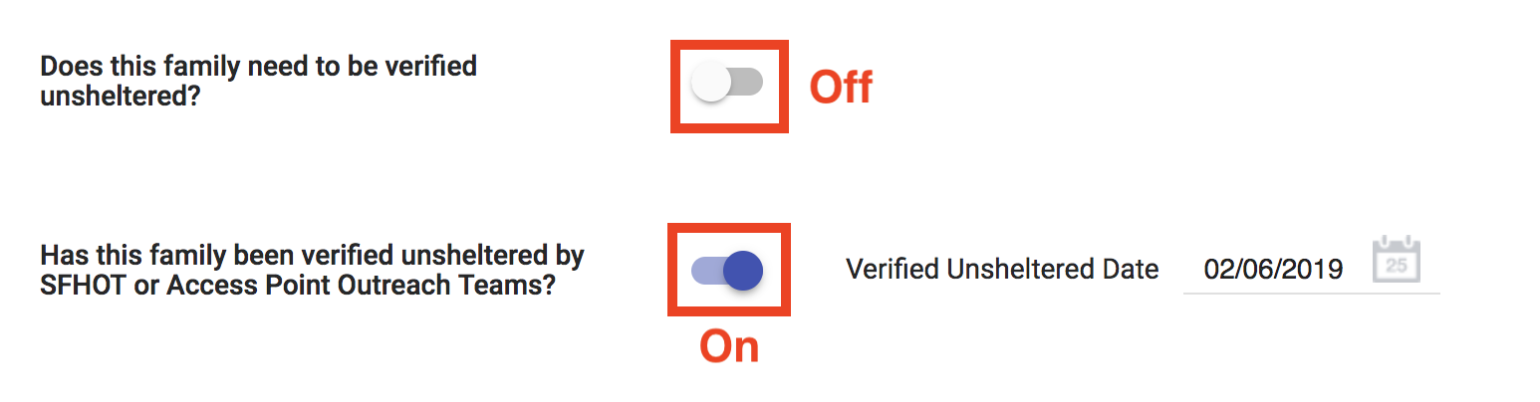
Viewing the Individual Shelter Room Placement List

Step 1: Navigate to the “Referrals” tab. 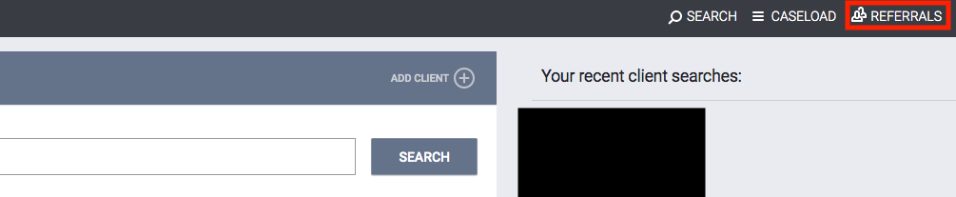
Step 2: Click the “Dashboard” tab and a list of the available dashboards will load on the right.
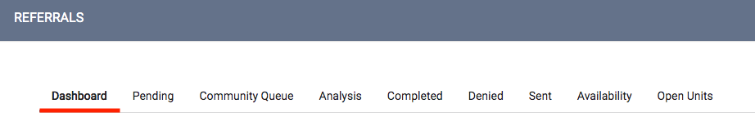
Step 3: Select the “*SF Family Individual Shelter Placement Criteria Dashboard*” which is located near the bottom of the list and it will load on that page.
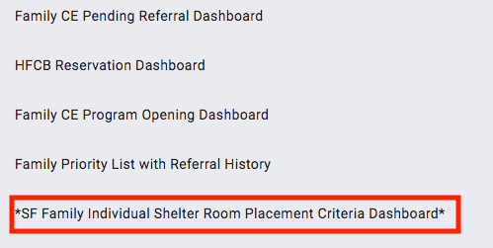
Step 4: View the “Individual Shelter Room Placement List” and scroll to the right to view the green columns. The family with the greatest amount of time in the “Calculated Length of Time in Shelter or Verified Unsheltered” column is the next in line for an Individual Room Shelter. 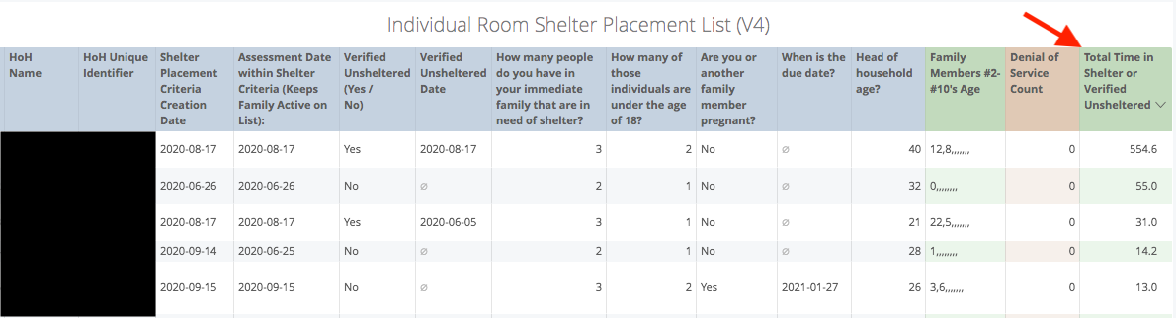

Scheduling Intake Appointments
In order for a family to qualify for Hamilton Family Congregate Beds (HFCB), they first need to be verified as unsheltered in their most recent ‘Shelter Placement Criteria’.

Step 1: Verified Unsheltered Families eligible for HFCB can be located on the “HFCB Reservation Dashboard”. Families who have been verified as unsheltered the longest will be at the top of the list and should be prioritized for placement at HFCB.
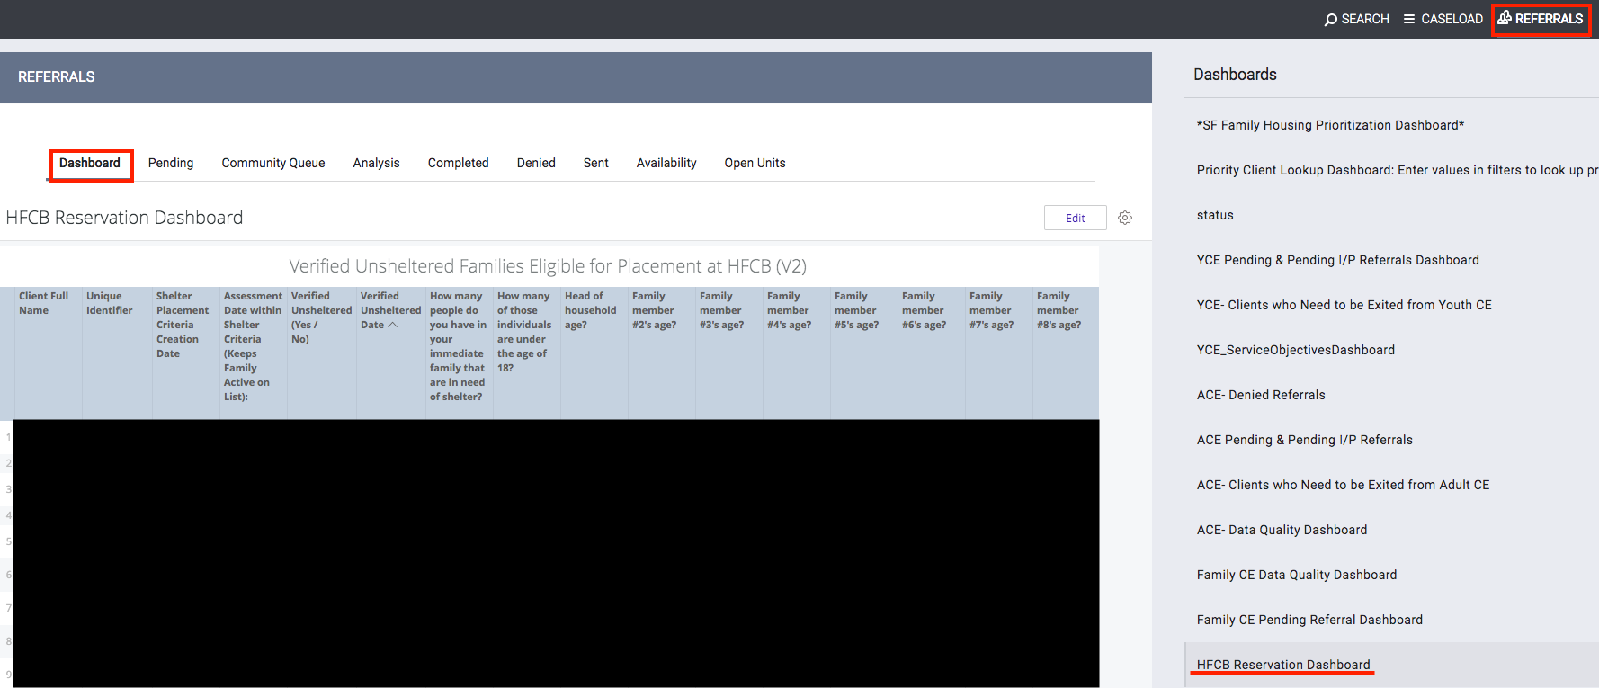
Step 2: Before reserving beds for a family at HFCB, you will need to verify that they have not been “Denied Service” by that agency. On the ‘Verified Unsheltered list’, check to see if the head of household has a ‘Denial of Service’ in the first orange column on the right of the table. If they do have a denial of service, scroll down to the ‘Active Denial of Service Summary Look’, find the client, and make sure that their denial was not at Hamilton Families. If it was, they cannot stay at HFCB.
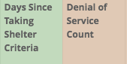
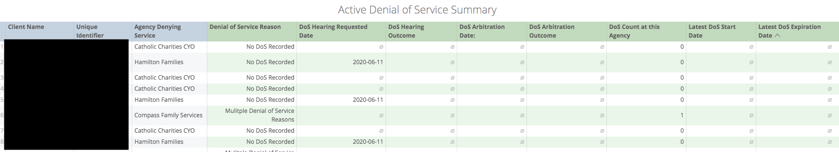
Step 3: If the prioritized family does not have a denial of service, the APs need to review the current bed openings at Hamilton Family Congregate Bed (HFCB) in the attendance tool and find the next opening available that fits the family’s size and age demographics. To do this:
- Switch to the “Hamilton Families” agency in ONE by clicking the drop down arrow underneath your name and selecting the correct agency.
- Click the “Launchpad” icon and then click “Attendance”.
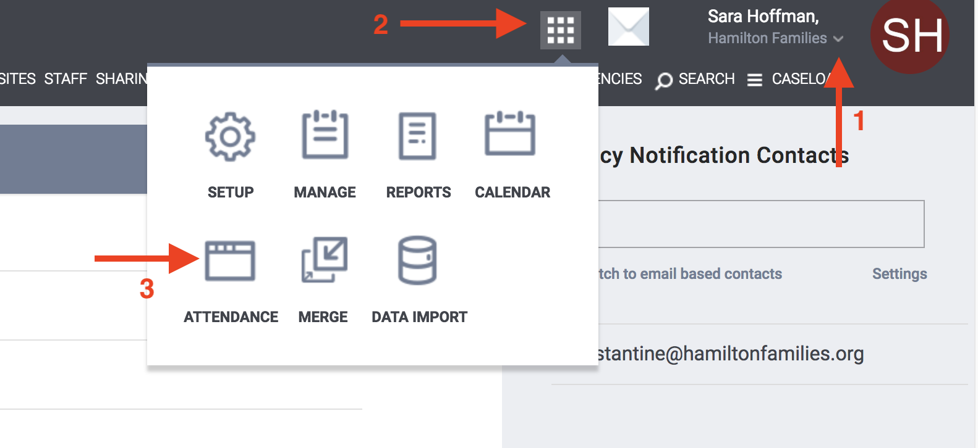
Step 4: Click “Reservation” for the “[Hamilton Family Emergency Center] Bed Night Service”.
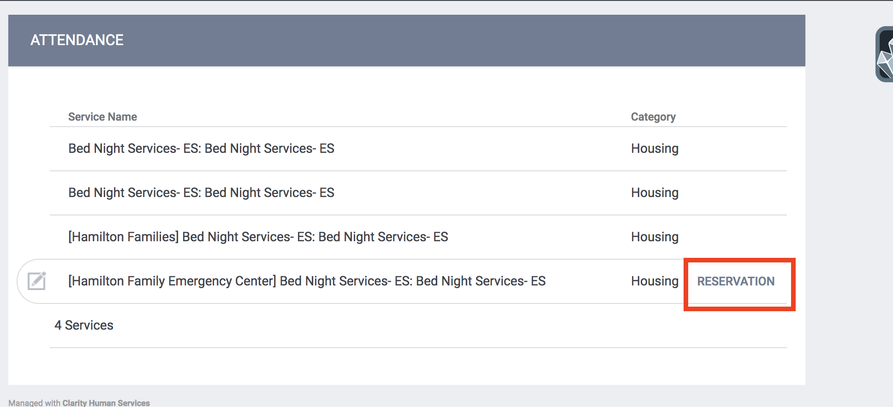
Step 5: When in the Reservation/Attendance tool, you will see various colored boxes. Each color indicates the following status:
- Blue indicates a reserved bed,
- Orange indicates a reserved bed where the person was marked “Present” for that particular day
- Red indicates a reserved bed where the person was marked as a “No Show”
- White indicates an unreserved bed.
Note: Children must be six years of age to sleep alone in a top bunk and must be under the age of five to sleep in a bottom bunk with their parents. Ten cribs are available to be reserved at the bottom of the attendance page.
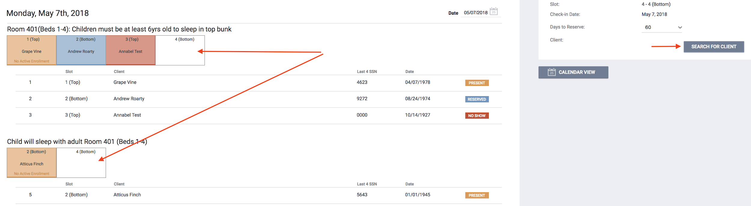
Step 6: Select the client you want to reserve a placement for then click “Preview reservation”.
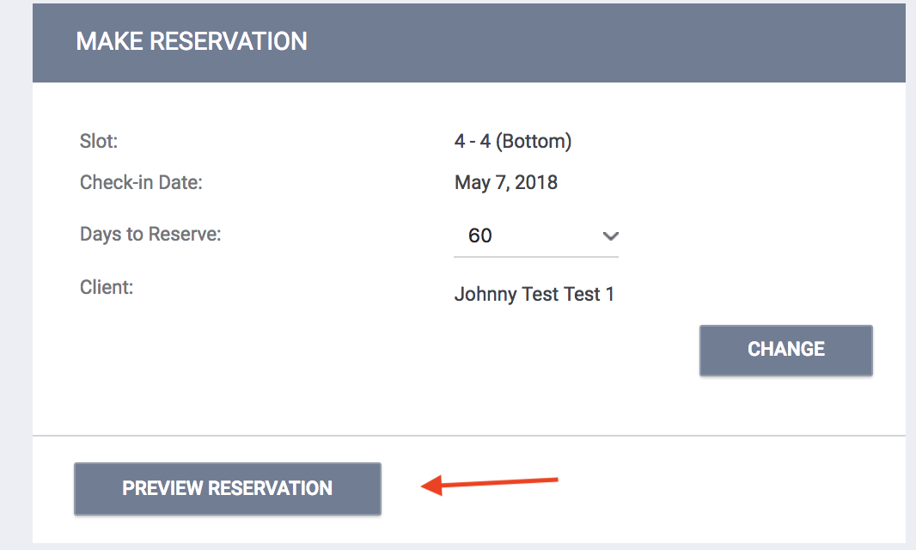
Step 7: Scroll to the bottom page and click “Confirm”. Note: APs should reserve the bed for five days and HFCB will update the reservation to the 60 day when they complete the client's intake.
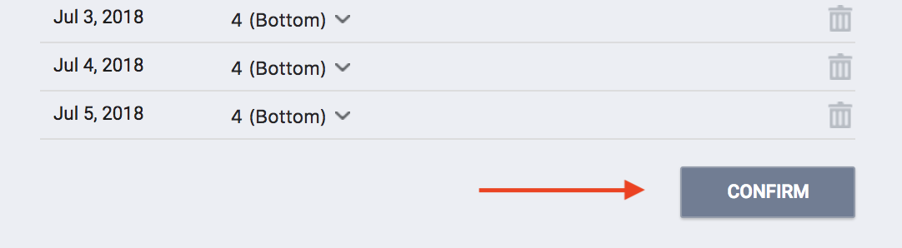
Step 8: Once a bed has been reserved, the APs will need to schedule an intake appointment for the family with HFCB. The intake appointment must occur prior to their bed reservation and must be scheduled at least 2 hours before the intake appointment time. APs can only schedule three intake appointments with Hamilton Families a day at the following set times:
- 10:00 AM
- 2:00 PM
- 5:00 PM
The first step in scheduling an appointment is to review the “Daily Count of Appointments Scheduled with HFCB by viewing the Appointment Time” Look (Below the ‘Verified Unsheltered’ Look on the “HFCB Reservation Dashboard”) to see when the next available intake appointment is.
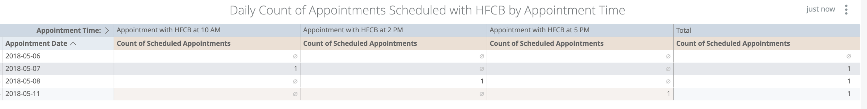
HFCB receives emails everyday at 8 AM, 12 PM, and 3 PM communicating what upcoming intake appointments have been scheduled. This is why it is a necessity that the intake appointments are scheduled at least 2 hrs before the appointment time.

Step 9: Once an open intake appointment time slot has been identified, click the “Services” tab in the client’s file to schedule the appointment.

Step 10: Click “Schedule Appointment With Hamilton Family Congregate Beds (HFCB)” service, select the appropriate time, and set the date of the appointment. Click “Submit”.
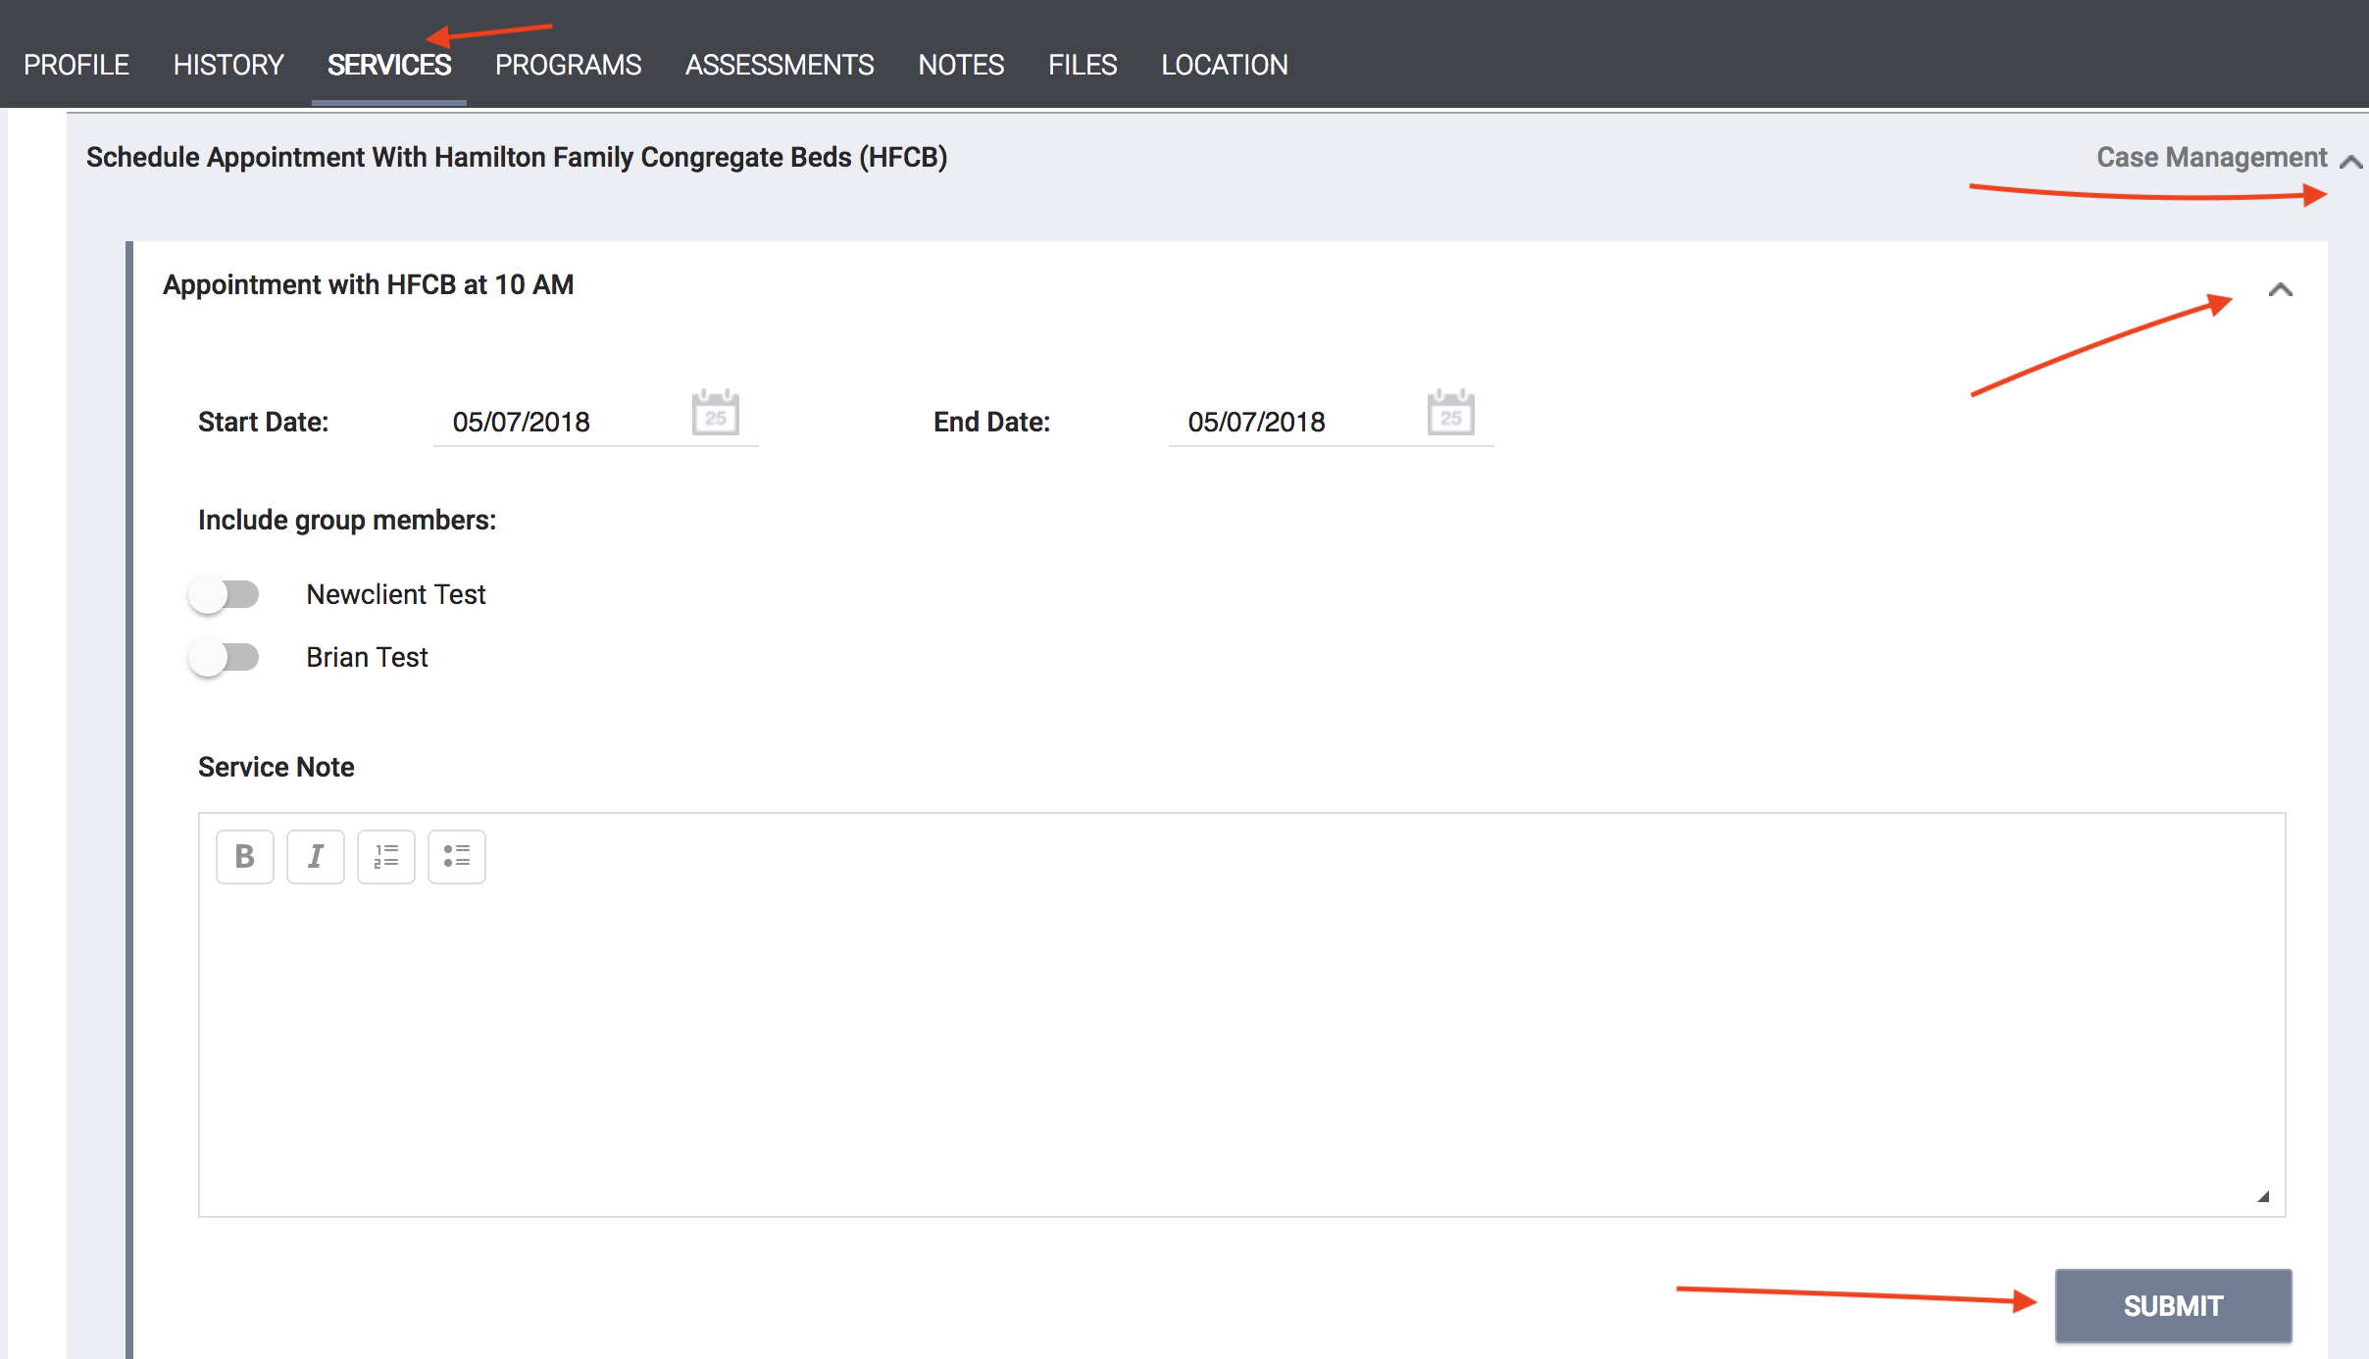
Step 11: That appointment will be reflected in the “Daily Count of Appointments” Look as well as the “Clients with HFCB Intake Appointment” Look located on the “HFCB Reservation Dashboard”. The following Looks are emailed to HFCB 3 times a day.
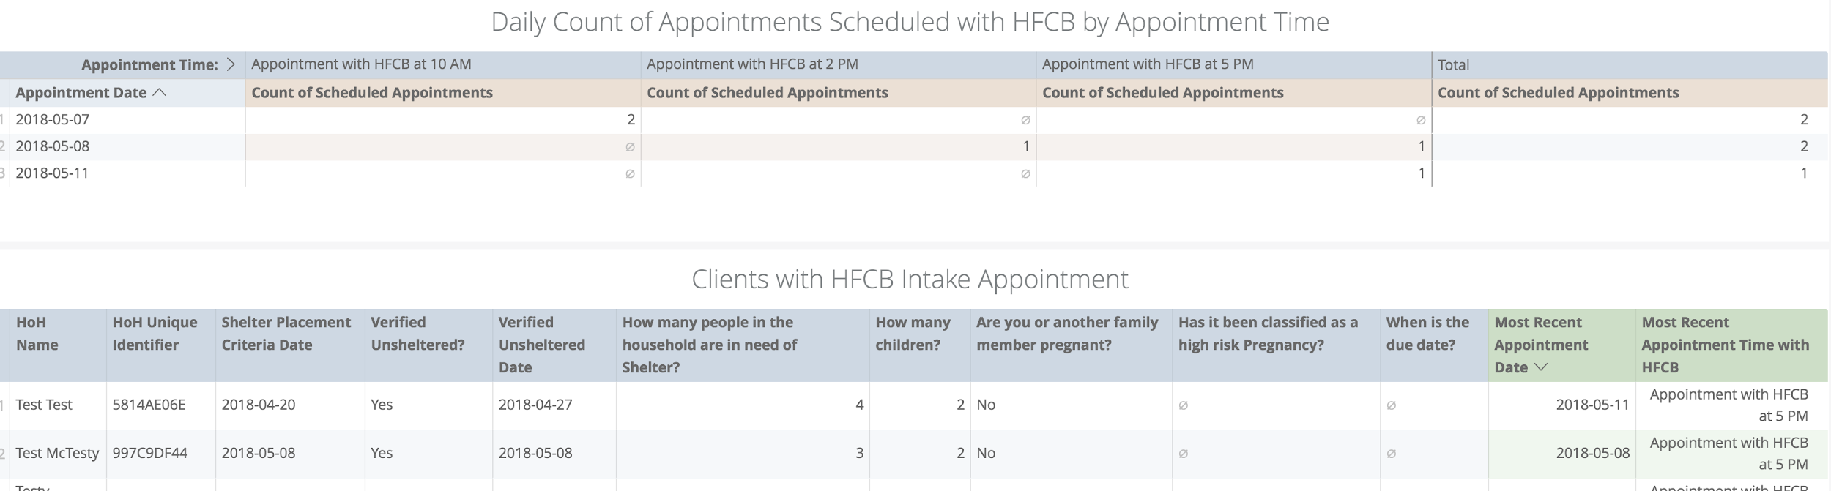
Step 12: With the Hamilton Families agency, HFCB staff will indicate if the family shows up for their scheduled intake appointment. To do this, they navigate to the “Service” tab and select the “Family Appointment Attendance Tracking” service.
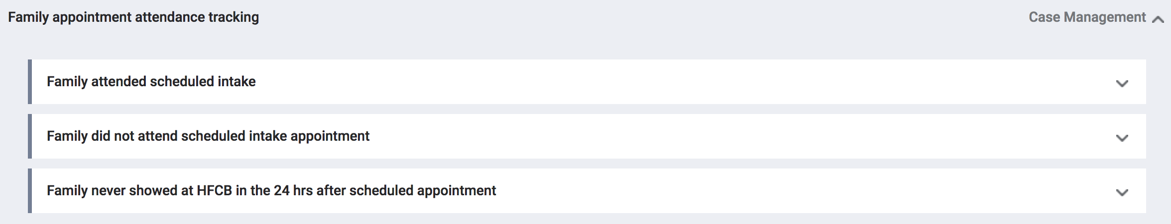
Step 13: If a family does not show for their appointment within 24 hrs, they should be removed from the “HFCB Verified Unsheltered list”. To do this click the “Assessment” tab. Scroll down to “Assessment History”.

Step 14: Click edit to the right of the families most recent “Shelter (Individual room) Placement Criteria” Assessment.
Step 15: Click the toggle to indicate that yes “Remove Family from the Hamilton Family Congregate Bed Placement List”. Then indicate why the family was removed from the ‘Verified Unsheltered’ List. If they ever need to be added back to the ‘Verified Unsheltered’ list, the toggle can be deactivated.
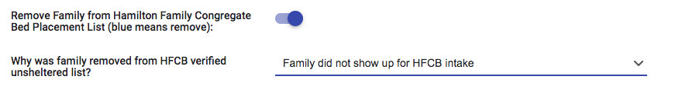

Referring to Individual Room Shelters
All families on the ‘Family Shelter Community Queue’ are eligible for placement in an Individual Room Shelter. APs can see everyone who is on the Family Shelter Queue by navigating to Referrals→ Community Queue→ Family Shelter Community Queue
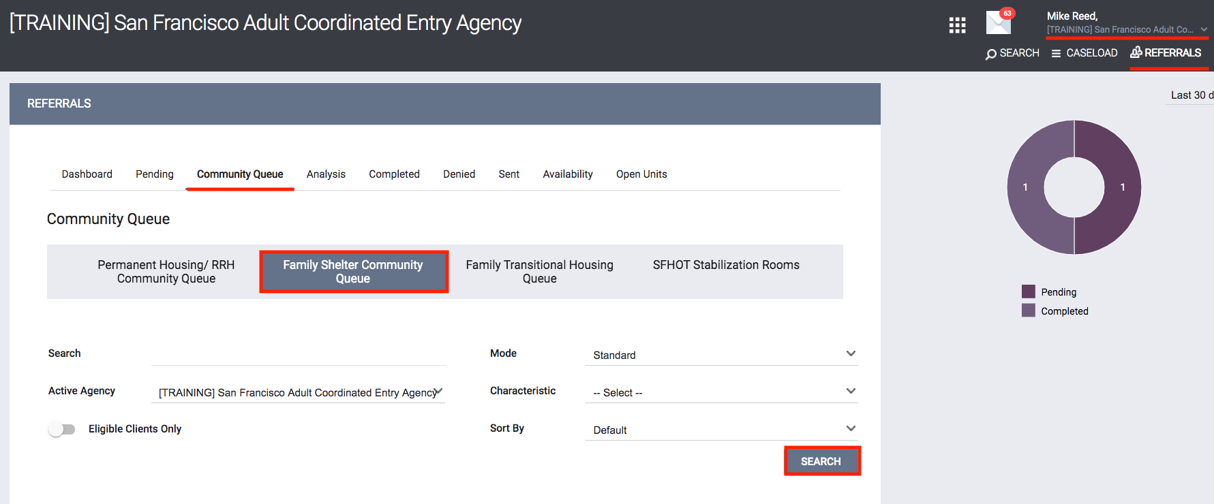
Step 1: Identify an open Individual Shelter Room to fill using either the “Open Units” tab or the “Current Family CE Shelter Program Openings” Look on the “*SF Family Individual Shelter Room Placement Criteria Dashboard*”
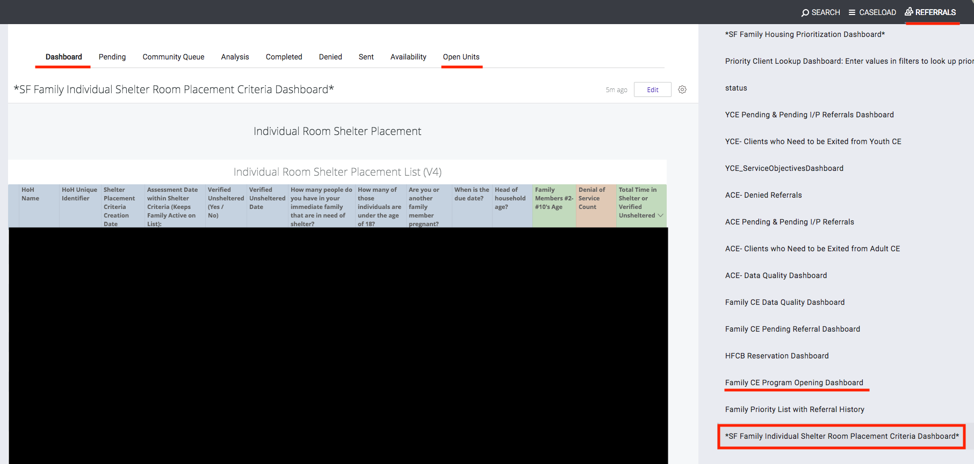

Step 2: The Current Family CE Shelter Program Openings Look summarizes all available shelter openings. When an AP staff decides to take responsibility for filling an opening they need to claim that opening which is captured in the far right column of the program opening Look. If no AP staff member name is present, then that opening has not yet been claimed.
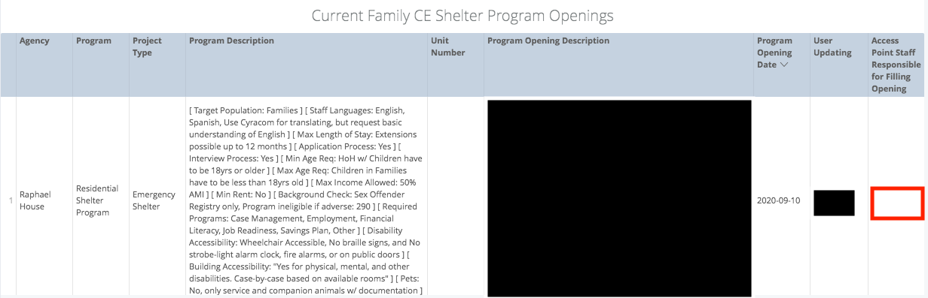

Step 3: To claim responsibility for a program opening, the AP staff need to switch to the agency that posted the opening, navigate to the Referrals→ Availability tab, edit the available opening, and enter the name of the AP staff under the “Access Point Staff responsible for filling opening”.
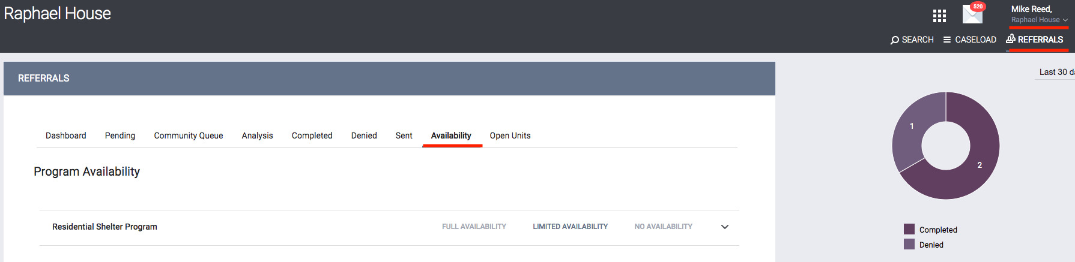
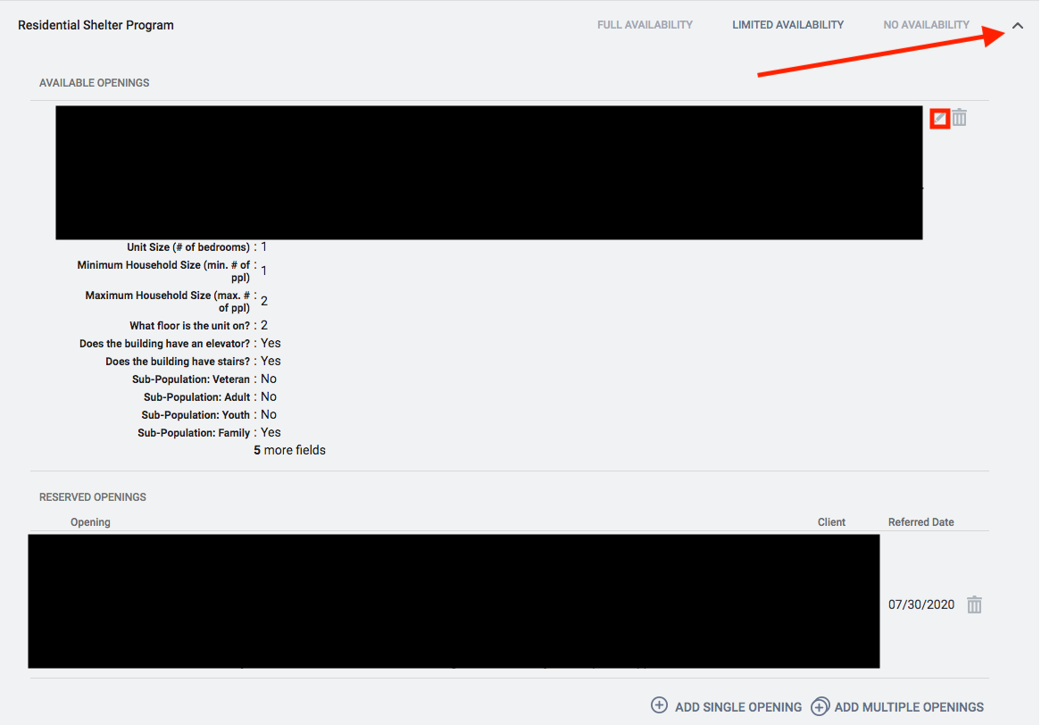
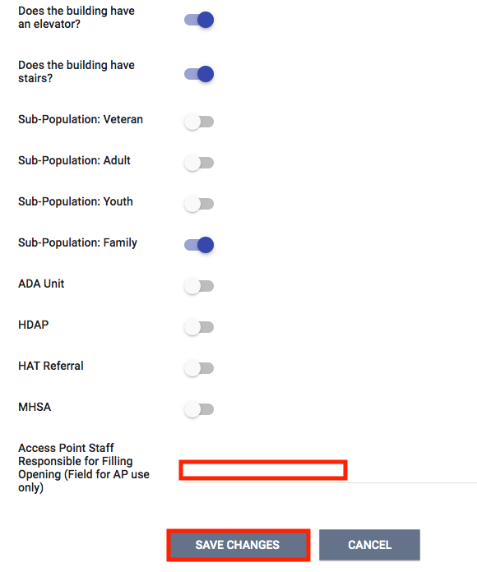
Step 4: Now that the AP staff member has claimed responsibility for the opening, they need to identify the highest priority family to refer to that opening. Families are Prioritized by the far right column “Total Time in Shelter or Verified Unsheltered” on the “Individual Room Shelter Placement List”. Identify the highest priority family that fits the specifications of the posted unit.
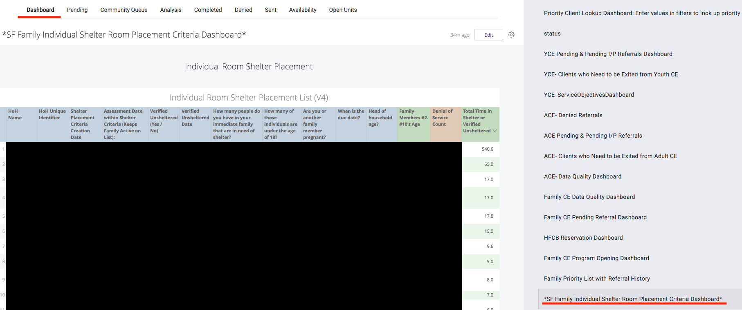

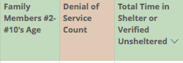
Step 5: Review the orange “Denial of Service” column to see if the client has any documented denial of services. If they do, scroll down to the “Active Denial of Service Summary” Look on the same dashboard. Locate the client and verify that their denial of service was not at the agency to which they are being referred. If they have a denial of service at the applicable agency, they cannot be referred there.

Step 6: The Matchmaking process for individual room shelter will be performed through the Family Shelter Queue. Navigate to the queue and perform the following steps:
- Enter the client’s name or unique identifier
- Active Agency= the agency you are referring to
- Search
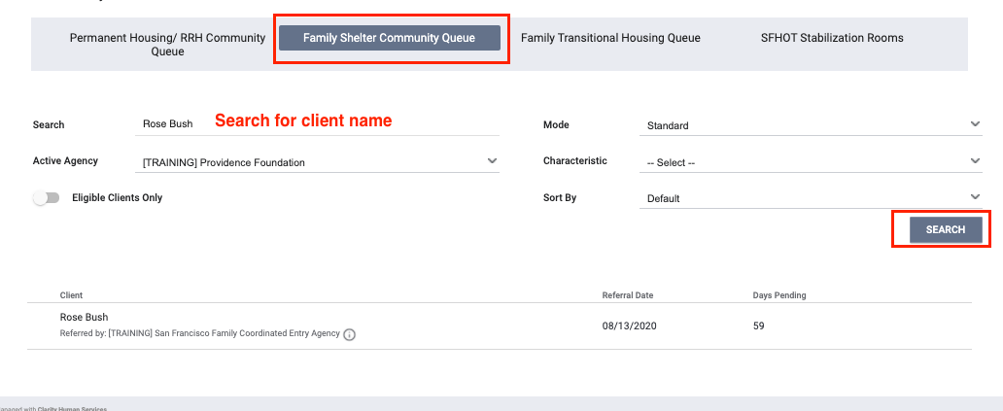
Step 7: The AP staff can click into the client’s referral on the queue by clicking the edit symbol next to the clients name. Within the referral they can assign themselves as the “Navigator”, so that the client appears in their “Caseload”.
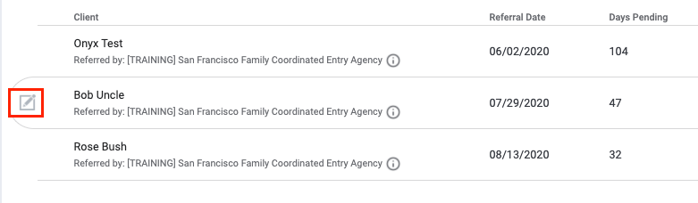
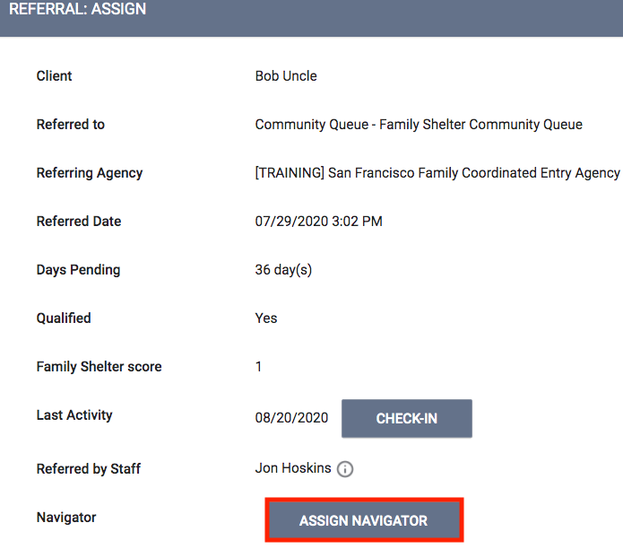

Step 8: The AP can then “Re-assign” the referral to the specific posted program opening that they are attempting to fill.
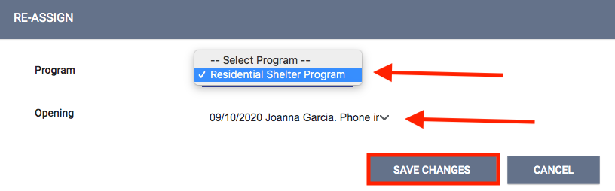
Step 9: The referred-to agency/program will receive a notification about the Pending Referral and will begin working with the client. If for any reason the client cannot be placed in the open unit, the referred-to program will deny the referral and send it back to the queue where the family will again be ready for matching. If the family moved out of the area or are no longer in need of shelter, the program will indicate that as part of the denial and has the choice to not send the client back to the community queue.
Step 10: Once a family has been successfully enrolled in an individual room shelter or TH program, they need to be removed from the other queue. On the *SF Family Individual Shelter Room Placement Criteria Dashboard*, there is a look called ‘Clients to be Removed from the TH or ES Queues’. This captures all clients that need to be removed from either the family shelter or transitional housing queues due to an enrollment in the other project type.
